Monday | Ordering numbers 0-50  Have a set of numbers on paper for your child e.g. 24, 32, 41, 29.  Which is the smallest number? How do you know?  Which is the largest? Explain how you know.  Choose one number:  What is one more than your number? What is one less?  Can you write as a calculation  e.g 23 + 1= 24  23 -1 = 22  Repeat using other numbers.
Tuesday | 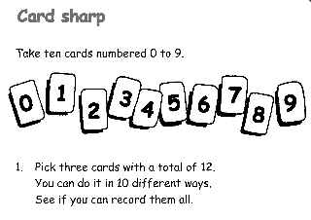  You need number cards 0-9 on paper.  Can you find which ones total 12? Are there any other ways to make 12?  Can you draw a picture to show this.
Wednesday | Watch video/ powerpoint on tapestry on 2D shapes.  Complete activity sheet: trace over and name shapes,  Talk about the link between 2D and 3D shapes
Thursday | Watch video/ powerpoint on tapestry on 2D shapes.  Complete activity sheet.
Friday | Watch video/ powerpoint on tapestry on 2D shapes.  Then give your child some give children 2d shapes – can they create their own pattern – photo for tapestry.

