03.11.17

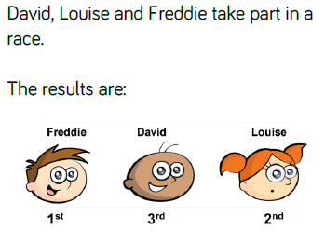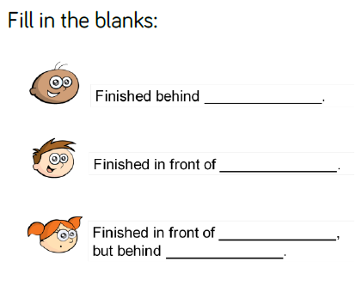WALT: use ordinal numbers

03.11.17

WALT: use ordinal numbers