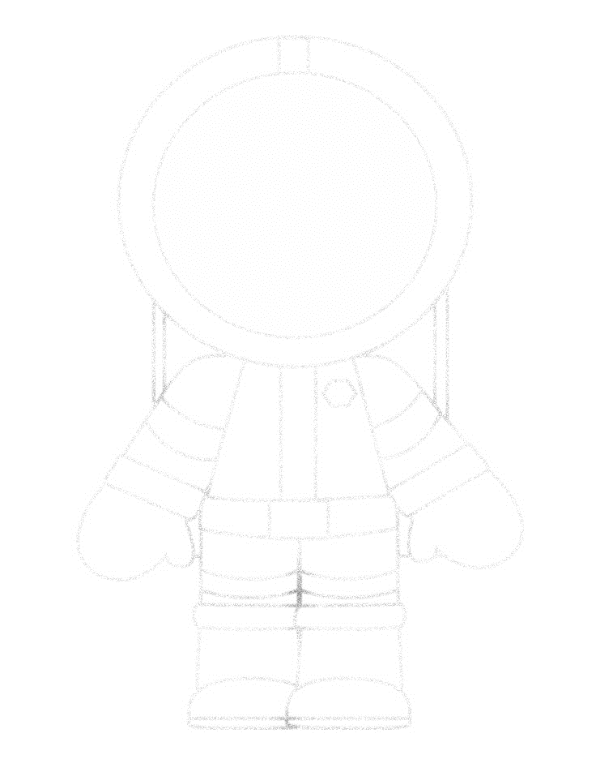

How does an astronaut’s body cope in space? 12.01.21