[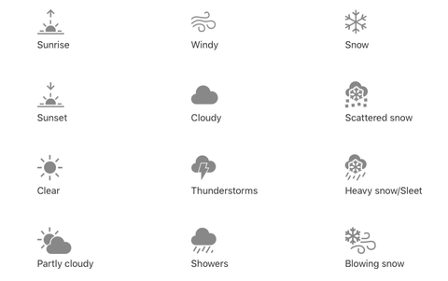](https://www.google.co.uk/url?sa=i&rct=j&q=&esrc=s&source=images&cd=&cad=rja&uact=8&ved=2ahUKEwjW6tbgqaHdAhVOFMAKHSW_DJoQjRx6BAgBEAU&url=https://www.cosmopolitan.com/uk/entertainment/a18729944/apple-iphone-weather-app-icons-meaning/&psig=AOvVaw37KT0BYXVRaJJGnDhb8W70&ust=1536149705351712)[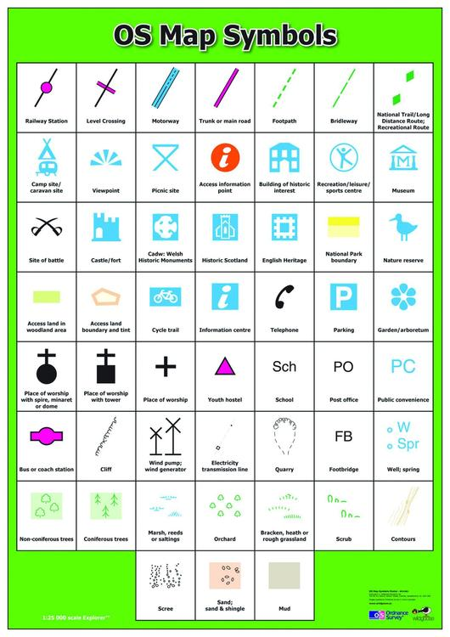](https://www.google.co.uk/url?sa=i&rct=j&q=&esrc=s&source=images&cd=&cad=rja&uact=8&ved=2ahUKEwjS_uq0qqHdAhVQFMAKHecyBVAQjRx6BAgBEAU&url=https://www.geopacks.com/products/os-map-symbols-poster&psig=AOvVaw2jmNPOLGKnwhN-v7YaWcVy&ust=1536149812630532)[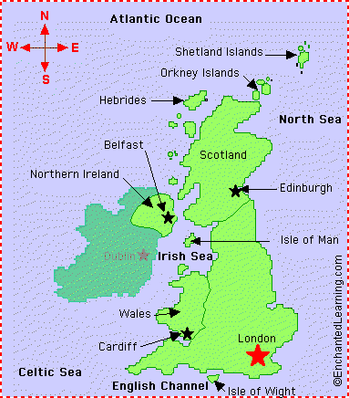](http://www.google.co.uk/url?sa=i&rct=j&q=&esrc=s&source=images&cd=&cad=rja&uact=8&ved=2ahUKEwjDp5O-qaHdAhUmD8AKHSu5DV8QjRx6BAgBEAU&url=http://www.digirev.us/map-uk-great-britain.html&psig=AOvVaw2y9ymHS5uRHhfdQSuqnJWd&ust=1536149583538766)

Aerial view – A map/photo taken from a high point and giving a birds eye view  
Atlas – A collection of maps  
Compass – A navigational device to find direction  
Globe – A scale model of earth  
Landmark – An object or feature of a landscape that has importance  
Map – A drawing of a place or places

**Key Vocabulary**

Physical geographical features: beach, cliff, coast, forest, hill, mountain, sea, ocean, river, soil, valley, vegetation, season and weather

Human geographical features: city, town, village, factory, farm, house, office, port, harbour and shop

Locational/directional language: near, far, left, right, behind, in front, next to

Compass points: north, south, east, west

Where in the world are we?