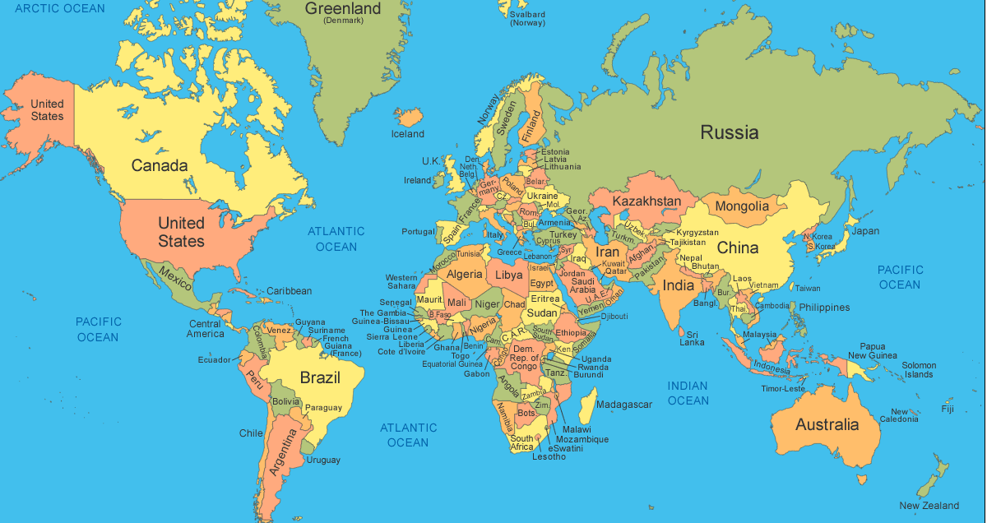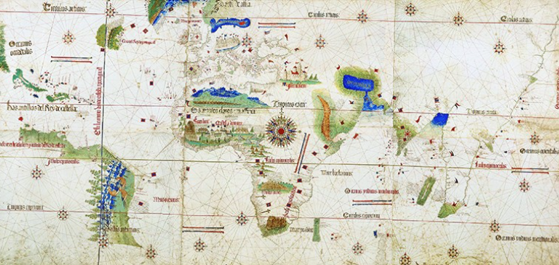

__________________________________________________________________________________________________________________________________________________________________________________________________________________________________________________________________________________________________________________________________________________________________________________________________________________

**Compare the map of the world from 1502 with the present day map.**

**What is the same and what is different?**