EYFS Enabling Environment Plan Term: 2 Week commencing: 30th November 2020 (week 5)
Topic: E is for Explorers ( Christmas starts!!) ART activities could be used as basis for Christmas Cards
Every Day:  Role Play  Outside  Including sand/water/mud kitchen | PD  (inc. Malleable Materials/Sensory Play} | PD: Funky Fingers | Literacy | Mathematics | The World  (Discovery/ICT) | EMM  (Art and Music)
MONDAY | Small World play set up | How quickly can you do up buttons on a cardigan?  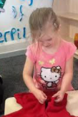 | 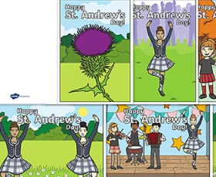  St Andrews Day cards | 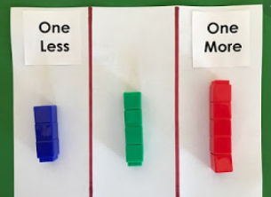  Find one more and one less using cubes | 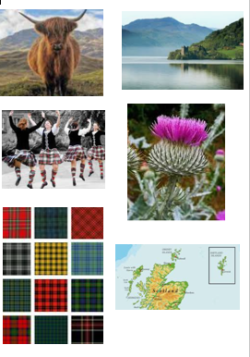  Scottish themed exploration- tartan, oats, loch ness pictures, Katie Morag stories, thistles, flags | 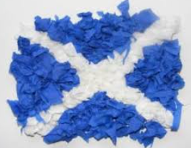  St Andrews Day art – large collaborative tissue collage Scotland Flag
TUESDAY | Decorate the tree – explore tinsel, baubles etc…  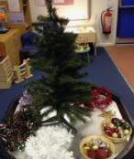 | Pine cones and elastic bands  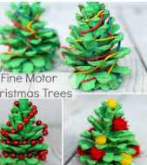 | 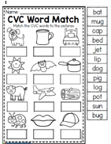 | 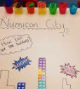  Numicon City | Flags and flowers of England, Ireland, Scotland, Wales | Design a flag for Uphill  Year 1 – drawing Experiment with different media pencil, crayon, pastel.
WEDNESDAY | Cut and stick to make a Christmas List - catalogues | Make paper chains  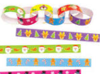 | 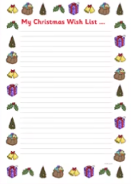  Write a Christmas List | Hole punch the trees  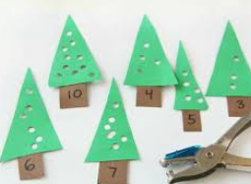 | 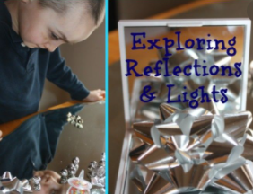  Explore reflection and light sing mirrors and foil, Christmas foil paper, ribbon | Christmas Tree Handprint Art  Year 1 - paint  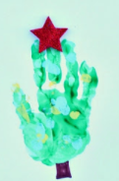
THURSDAY | Set up Nativity scene ( small world) | 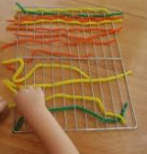  Weaving on a baking tray  DT – textiles. Year 1 | Writing Christmas cards – set up Postbox | 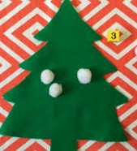  Roll the dice and decorate the tree | The Christmas Story – books and pictures to order | Christmas Weaving  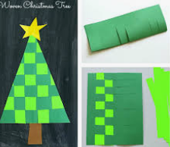  DT – textiles. Year 1
FRIDAY | Decorate the tree – explore tinsel, baubles etc… | 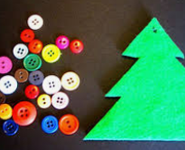  Decorate a tree | 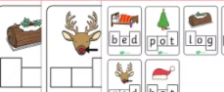  Christmas CVC words phoneme frames with magnetic letters  Cut and stick activity also | 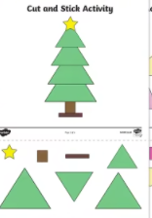  Christmas shape cutting activity | The Christmas Story – books and pictures to order | Design a bauble/Make a bauble  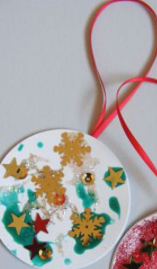  Year 1 3D –Add decoration.

