EYFS Enabling Environment Plan Term: 2 Week commencing: 14TH December 2020 (week 7)
Topic: E is for Explorers
Every Day:  Role Play  Outside  Including sand/water/mud kitchen | PD  (inc. Malleable Materials/Sensory Play} | PD: Funky Fingers | Literacy | Mathematics | The World  (Discovery/ICT) | EMM  (Art and Music)
MONDAY | Christmas play dough or salt dough or pastry  - Roll out and use Christmas cutters | Decorate a tiny tree  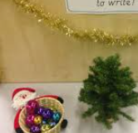 | Phonic Game from classroom | 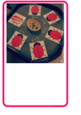  Ladybird adding | Christmas cards, stories, pictures  Ipad explore Christmas Apps – Santa Tracker, Santa’s Home, Elf yourself! | 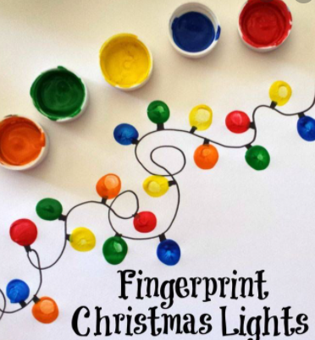  Fingerprint lights  Year 1 – paint.
TUESDAY | Wrapping presents  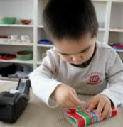 | Fine motor xmas trees  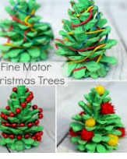 | 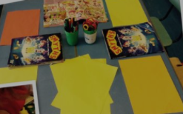  Cut out pictures from toy store catalogue and label to make a list | 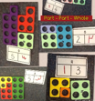  Find numicon to match part part whole | Christmas cards, stories, pictures  Ipad explore Christmas Apps – Santa Tracker, Santa’s Home, Elf yourself! | Paper strip trees  Year 1 - collage  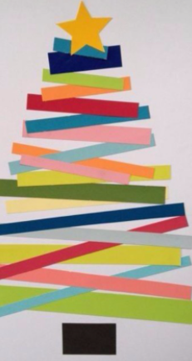
WEDNESDAY | Christmas play dough or salt dough or pastry  - Roll out and use Christmas cutters  Year 1 – 3d. | Cutting skills activity:  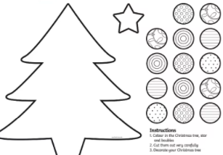 | Children to draw / label what they are looking forward to doing over Christmas. | Find numicon to match part part whole | Christmas cards, stories, pictures  Ipad explore Christmas Apps – Santa Tracker, Santa’s Home, Elf yourself! | Snowmen picture  Year 1 – paint.  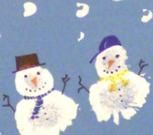
THURSDAY | 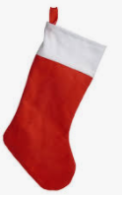  Fill the stockings – who can get the most in? | 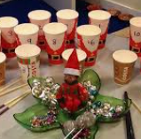  Help Elf count the baubles – use chopsticks/tweezers | Christmas stocking list: | 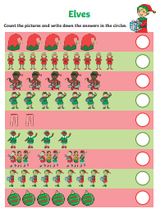  Elf counting sheet | Christmas cards, stories, pictures  Ipad explore Christmas Apps – Santa Tracker, Santa’s Home, Elf yourself! | Christmas stockings  