EYFS Enabling Environment Plan Term: 3 Week commencing: 4th January 2021 (Week 1)
Topic: S is for Space Stories (Mini Winter Topic)
Every Day:  Role Play  Outside  Including sand/water/mud kitchen | PD  (inc. Malleable Materials/Sensory Play} | PD: Funky Fingers | Literacy | Mathematics | The World  (Discovery/ICT) | EMM  (Art and Music)
MONDAY | INSET
TUESDAY | 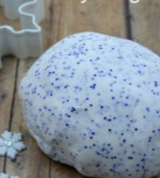  Two ingredient sparkly playdough  ½ cup hair conditioner  1 cup cornflour  (Blue sparkles!) | 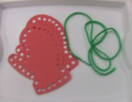  Mitten threading | Writing – What did you get for Christmas.  And  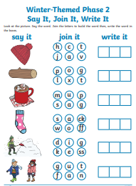  Phase 2 activity | 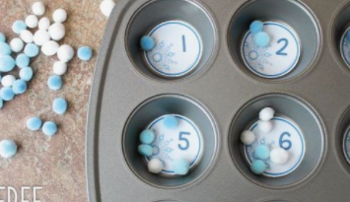  Snowflake painting into muffin trays | 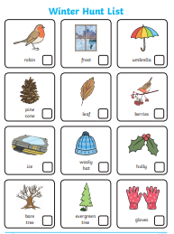  Winter Hunt checklist | 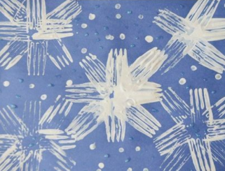  Fork snowflake painting
WEDNESDAY | 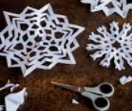  Cutting snowflakes | 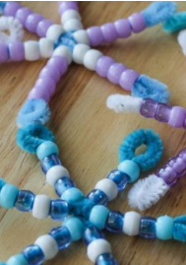  Threading/beading | 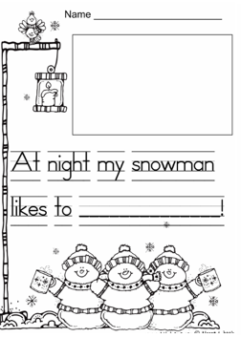  Snowman writing frame  Phonic Activity from classroom | 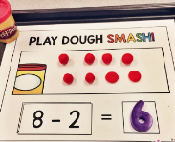  Playdough number smash subtraction | Winter LISTS  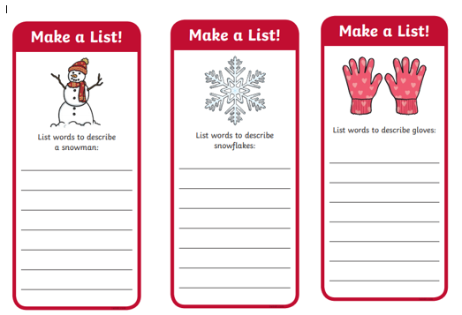 | 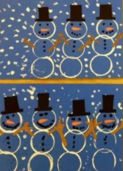  Snowman cup printing
THURSDAY | Playdough | 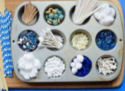  Make a snowflake tinker tray | 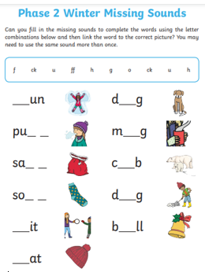  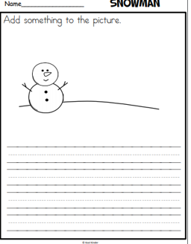  Snowman writing frame | 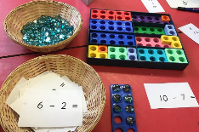  Playdough number smash | 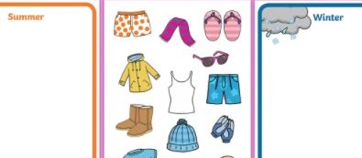  Winter/summer clothes sorting | 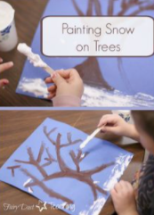  Winter trees
FRIDAY | 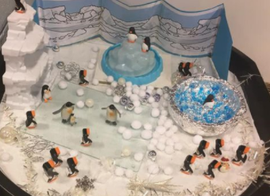  Snowy Tuff Tray (Antartic) | 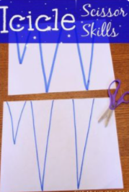  Icilcle cutting skills | 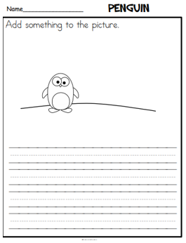  Penguin writimg frame | 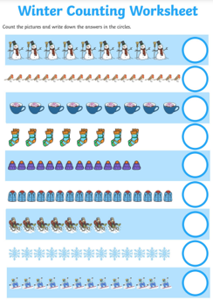  winter counting sheet | Antartic animals poster and colouring sheets  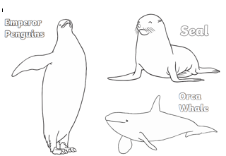  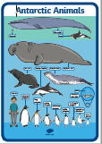 | 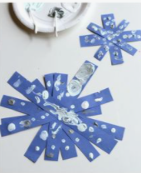  Snowflakes

