EYFS Enabling Environment Plan Term: 2 Week commencing: 7TH December 2020 (week 6)
Topic: E is for Explorers ART activities could be used as basis for Christmas Cards
Every Day:  Role Play  Outside  Including sand/water/mud kitchen | PD  (inc. Malleable Materials/Sensory Play} | PD: Funky Fingers | Literacy | Mathematics | The World  (Discovery/ICT) | EMM  (Art and Music)
MONDAY | Write in the sparkles/glitter  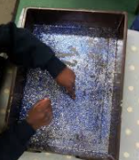 | Fine motor xmas trees  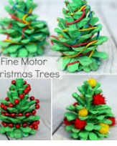 | Write an invitation to a Christmas party | 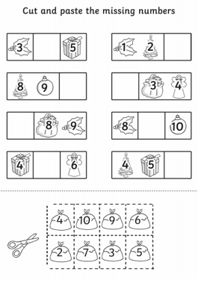  Cut and paste numbers in order | Christmas cards, stories, pictures | Handprint Christmas Trees  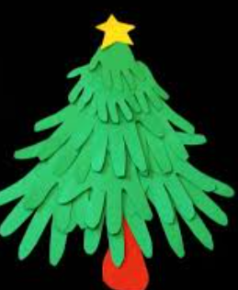  Cut around hands to make a tree
TUESDAY | 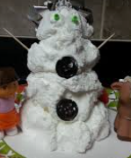  Shaving Foam Snowmen  Year 1 3d – manipulate malleable materials | Candy Cane threading  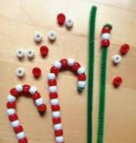 | Phonic Game form classroom | 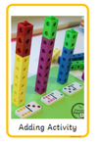 | Christmas cards, stories, pictures | Thumbprint Candy Cane  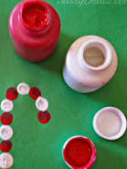  Year 1 – paint.
WEDNESDAY | Christmas play dough  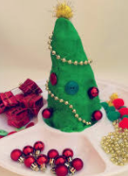  Year 1 3d – manipulate malleable materials | Decorate a tiny tree  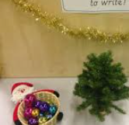 | 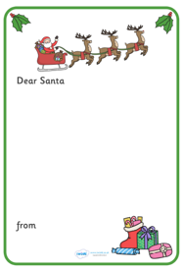  Letters to Father Christmas | 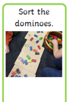  Sort dominoes by total number of spots | Christmas cards, stories, pictures | Cake case tree
THURSDAY | Make Reindeer Food  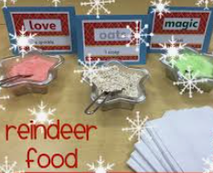 | Decorate the tree  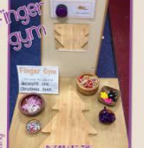 | Letters to father Christmas | 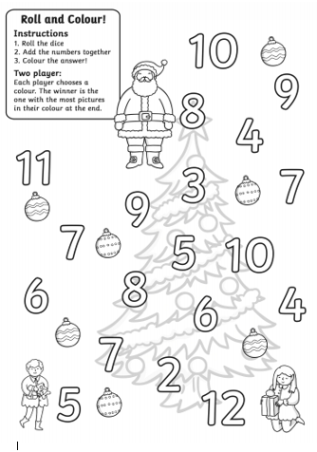  Roll, add and colour game | Christmas cards, stories, pictures | Reindeer Art paper folding  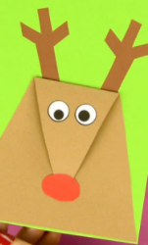  Year 1 – 3d art.
FRIDAY | 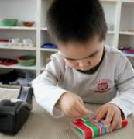  Wrapping presents | Decorate a snowman  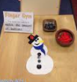 | 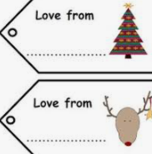  Write a label for a present | 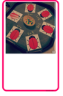  Ladybird Addition | Christmas cards, stories, pictures | Tissue Paper collage trees  Year 1 collage.  