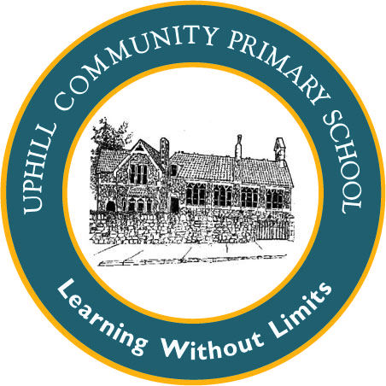Uphill Primary School EYFS Mathematics Plan

TERM 2 Weeks 3 and 4

|  |
| --- |
| Week 1: 2D shape |
| Week 2: 2D shape |

|  |  |  |
| --- | --- | --- |
| **Objectives:**  Use names for flat 2D shapes  Describe shapes  Select a named shape  **Misconception**: Children may not recognise shapes if they are constantly given the same shape in the same orientation – the classic example is the square on its point, some children will say it is a diamond. | **Reasoning Opportunities/ Probing Questions**  Show me a ________, show me NOT a _____________.  Which shape is in the wrong place on this sorting table? How do you know?  Use the class character or puppet to make language and sorting errors when dealing with shapes, which the children need to correct. | **NRICH links**  NRICH EYFS: Shapes in the bag  NRICH EYFS: Exploring 2D shapes  NRICH EYFS: Building Towers |

|  |
| --- |
| **Suggested Activities:**  **DAILY COUNTING 0 -10 forwards and backwards** and Number rhymes (ten green bottles, five little ducks, ten fat sausages, five little aliens, five  speckled frogs etc.)  **Week 1:**  **MON:** Sit children in a circle – place 2D shapes/paper shapes on floor. Q. *Can you find all the shapes with straight sides? Can you find any more shapes that have straight sides in the room? Q. What are the shapes with straight sides called? Q. What is the difference between a square and a rectangle? Q. How many sides do they have? Q. How many corners do they have? Give each child either a square or rectangle and go on a shape hunt for squares and rectangles. Take photos.*  ***Continuous Provision Art Area:* Mondrian inspired art:**  **TUES**: Sit children in a circle – Put pieces of string on floor. Q. Can you make a square with the strings? How many will you need? Q. Will the pieces of string need to be the same length? Q. Can you make a rectangle with the string?  Make a triangle with 3 pieces of string – Q. What is this shape called? Q. How many sides does it have? Ask children to make a triangle with 3 pieces of string. Q. How many corners does the triangle have?  Use Early Years Maths Pack ‘Shape paint’ and model making pictures using triangles, squares and rectangles.  **Continuous Provision Art or Maths Area:** use cubes, cuboids and triangular prisms to print squares, rectangles and triangles.  **WEDS:** Sit children in a circle – place 2D shapes/paper shapes on floor. Q. *Can you find all the shapes with straight sides? Sort the shapes. Q. What shape has no straight sides? Introduce circle.How many circles have we sorted? Give each child a circle and go on a circle hunt. Take photos.*  **Continuous Provision Maths Area: make a circle using dot stickers.**    **THURS:**Display 2D shape posters. Introduce hexagon. How many sides does the hexagon have? How many corners? Make a hexagon using lolly sticks. Find the hexagons in a selection of 2D shapes on the floor. Check by counting.  Ask children to use their fingers to show you the number of sides and corners different shapes have.  Choose a shape to describe to the children, who can tell you the name of the shape you are describing.  Song: Feely bag, what’s inside? What’s the shape you try to hide? Is it circle, rectangle, triangle or square? Feel inside describe what’s there.  **Continuous Provision Maths Area: challenge children to make straight sided shapes using matches/ lolly sticks/construction straws**  **FRI:** Draw large shapes with chalk outside( or use masking tape inside) Ask children to stand in the different shapes. Challenge children to make shapes using themselves. Q. How many children will you need to make a triangle shape? A square? How can we make a rectangle with two longer sides?  **Week 2**  **MON:** Introduce octagon- make link with octopus. Q. How many sides does the octagon have? How many corners? Find the octagons in a selection of 2D shapes.  Display 2D shape posters. Use 2D shape fans. Describe a shape, children show answer using fans.  **TUES:** Choose a shape to describe to the children, who can tell you the name of the shape you are describing.  Play 2D shape bingo.  **Continuous Provision Maths Area: 2D shape pizza – how many of each shape did you use on your pizza?**  **WEDS:** Draw a five sided shape on board – how many sides does this shape have? Is it an octagon? Why not? Is it a square? Why not? Name it as a pentagon.Draw different pentagons on board. Check they are pentagons by counting sides. Draw a six sided shape, can children name it?  Use TWINKL powerpoint Everyday2D Shapes to identify and describe 2D shapes  **Continuous Provision Maths Area: 2D shape sorting activity TWINKL**  **THURS:** Choose a shape to describe to the children, who can tell you the name of the shape you are describing.  Play 2D shape bingo.  **Continuous Provision Maths Area: 2D shape sorting activity TWINKL**  **FRI:** Shapes in the bag activity. Ask children to feel a shape in a bag and describe it to the others – other children could guess using shape fans. If children struggle to describe by feeling alone they could secretly have a look then describe. Focus on number of sides and corners.  Hide a shape behind a piece of card, slowly reveal it. Q. What could this shape be? What can it not be? Why?  **Other ideas for continuous provision**:        |