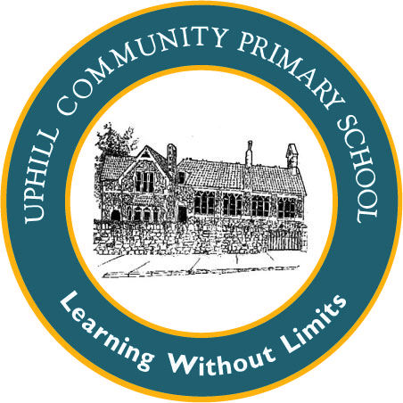
Uphill Primary School EYFS Mathematics Plan
TERM 2 Weeks 5 and 6
Week 5: Adding
Week 6: Adding

Objectives:  Finds the total number of items in two groups by counting all of them  NB: There is no expectation that children in the EYFS write symbols and calculations to record  their mathematical thinking although they may choose to make their own jottings and mark making to support their learning. We will be showing them the symbols though. | Reasoning Opportunities/ Probing Questions  Show me five on the tens frame. Show me another arrangement of five. Now another and another.  If I have 5 teddies altogether and I need to put them into two boxes, how many could I put in each box? Is there more than one way I could pack them? How many ways can you find altogether? | NRICH links

Suggested Activities:DAILY COUNTING 0 -10 forwards and backwards and Number rhymes.
Week 5:
MON: Use counters of your choosing, grab some with one hand and some with the other. I have 3 in this hand and 2 in this hand how many do I have altogether? Model counting all the counters to find out, saying 3 and 2 are 5 altogether. You could also say 3 add 2 is 5 and write it on board 2+3=5. Repeat. Model dice game with a child: Give pairs of children a dice and counters, each child rolls a dice to collect counters. How many have you both collected? NB use a 1-3 die to support. SG has some blank dice in Rainbow.
TUES: Show a large domino – look at dots on one side, get that number of cubes (in one colour) look at dots the other side get that number of cubes in another colour. Put cubes together in a tower to find out how many dots altogether. Say 3 and 4 is 7 altogether, write 3 + 4 =7. Repeat asking children to make the towers. Show a ready-made tower of 2 green and 4 red cubes. Q. What domino would match this tower? Leave out similar activity in maths area. Children can make towers to match the dominoes or find dominoes to match the towers:
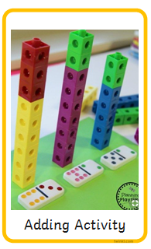
WEDS: Use large dominoes and model counting all the dots on a domino to find the total number of dots. There are 3 dots this side and 3 dots this side. 3 and 3 is 6 dots altogether; write on board 3+3= 6. Repeat. Give pairs of children some dominoes. Ask them to find a domino with a given total- you could draw all the different dominoes to share with the class. Open Early Years Maths Pack ‘Adding and Subtracting’ Domino Pop game. Children have to count the total spots on a domino and check their answer by popping the balloon. They could use number fans to show answers. In maths area ask children to sort dominoes:
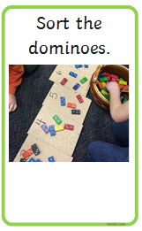
THURS: Give each child a tens frame and counters in 2 colours. Roll a die on the SMART board – children count out that number of counters on tens frame. Roll die a second time, count out that number. How many counters do we have altogether? Say and write the calculation you make. Repeat. Open Early Years Maths Pack ‘Adding and Subtracting’ Domino Pop game. Children have to count the total spots on a domino and check their answer by popping the balloon. They could use number fans to show answers.
FRI: Draw a ladybird on SMART and have 6 circles that can be moved onto it ready on the board. Invite children to fill the ladybird with 6 spots. How many different ways can we do it? Model saying 2 spots and 4 spots make 6 spots altogether encourage children to repeat you. Write 2+4=6 Give pairs of children a blank ladybird template and 8 counters, ask them to place their spots and tell the class the arrangement they have made. Leave this activity in maths area:
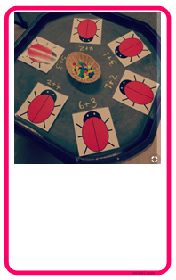

Week 6 DAILY COUNTING 0 -10 forwards and backwards and Number rhymes.
MON: Give children a domino each. Ask them to find other children who have the same total number of spots as they do. Ask them to explain their totals ( I have a domino with 2 spots and 3 spots. It has 5 spots altogether) Open Early Years Maths Pack ‘Adding and Subtracting’ Domino Pop game. Children have to count the total spots on a domino and check their answer by popping the balloon. They could use number fans to show answers. Leave this activity in maths area:

TUES: Have 5 wrapped up presents. Explain that you want to put them into two stockings. Q. How many could I put in each stocking? Ask children to put the presents in. Model saying I have 2 presents in this stocking and 3 in this one making 5 altogether. Write down each combination as a part/part whole model. 
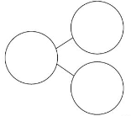

Model activity in maths area. Roll dice and place that number of counters in one part. Roll dice again and put that number in other part. Add two parts and write total number in whole.
In maths area leave out laminated part/part whole models and counter/dice( I have put some on third page of this document)

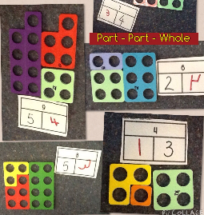
WEDS: Display a part/part whole model with 5 in the whole. Q. How can we complete the two parts? Q. Can we use numicon to help us? Who can find two pieces that make 5? Complete the part/part whole model. Repeat for a different number. Leave this activity in maths area:

THURS: Give each child two numicon pieces and ask them to find the total of the two pieces. Encourage them to say I have a 2 piece and a 4 piece which is the same as a 6 piece. Children could put counters on the top of the pieces so that they have physical objects to count. Q. Who could complete a part/part whole model for their pieces? Repeat with other children.
Leave out numicon activity(as Wednesday)
FRI: Open Early Years Maths Pack ‘Adding and Subtracting Dice Addition’. Children have to select two dice that make the given total. Relate to part/part whole models. Give out counters or numicon to help. Write up the part/part whole model each time for the children to see.

    

