EYFS Home Learning Mathematics Plan
Week beginning 11th January
There will be a memo on Tapestry each day with a short video clip to accompany these activities. Please upload photos of your child completing any of the activities. Thank you!
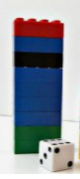
Suggested Activities:
Monday: Lego Tower Subtraction race
Build a Lego tower for you and your child (up to 20 bricks tall) Take turns rolling a dice and taking away that number of bricks. The winner is the first person to demolish their tower. 
Resources needed: Lego or building bricks( or you could use a pile of coins) dice
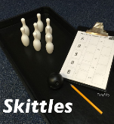
Tuesday: Subtraction Bowling
Use toilet/kitchen roll tubes as skittles. I had 8 skittles, I knocked over 2 and how many are still standing? Write as a number sentence for your child - 8 – 2 = 6. Say ‘8 take away 2 is 6, 8 take away 2 is 6, 8 subtract 2 is 6.’
Resources needed: real skittles or cardboard tubes and small ball
Wednesday: Subtraction on a tens frame.
Use the tens frames template (or you could use an empty 10 egg carton) Ask children to place a given number of counters onto the tens frame. Ask them to take away a number (you could roll a dice to determine how many to take away) How many are left?
Say ‘we had 8, we took away 4, this left us with 4. 8 take away 4 is 4. 8 subtract 4 is 4.’ Repeat.
You could record this as number sentence for your child. 8-4=4
Resources needed: tens frame and pasta counters (optional 10 egg carton/dice)
Thursday: Space Subtraction
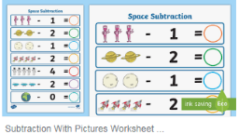
Count the space objects and strike through the number to be taken away. Write the answer. You can also place counters (pasta) on each picture and physically take away the number given.
Resources needed: space subtraction sheet and pasta counters
Friday: Reading subtraction calculations
Write some subtraction calculations onto pieces of paper and place on plates ( e.g. 6 – 4, 8 – 3, 7 – 5) Ask your child to read the calculation and solve it by using counters. For 7 -5, they would count 7 counters onto the plate and then take away 5. Say ‘ We had 7, we took away 5 which left 2, 7 take away 5 leaves 2, 7 subtract 5 is 2 . You could use pasta, biscuits, sweets or coins as counters.
Resources: plates, paper, counters

