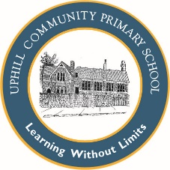
Uphill Primary School EYFS Mathematics Plan
Week 1 and 2 Term 3

Objectives:  Use objects to subtract  For Expected achievement  Using objects and quantities children add and subtract using two single digit numbers  They count on or back to calculate | Reasoning Opportunities/ Probing Questions  Use a character or puppet to make deliberate mistakes when adding,subtracting or sharing. Ask the children to correct the mistakes. | NRICH links

Suggested Activities:
Monday: Sing song Five Little Speckled Frogs (or alternative counting back song) with accompanying concrete resources. There were 5, one jumped off now there are 4. Model drawing five spots and striking through 1 to leave 4. Model writing 5 – 1 = 4. Repeat for other verses of the song.
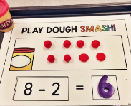
Give children 5 counters. Ask them to line them up and then take away 2. How many left? Repeat for taking away 3, 4, 5,1 and 0 from 5. Model playdough smash for tomorrow’s provision. 

Tuesday: Sing Five Currant Buns (or alternative counting back song) with accompanying concrete resources.
Draw 5 currant buns and invite a child to strike through a given number – how many left? Use concrete resources as well. Repeat for other children. Use playdough smash as a group.
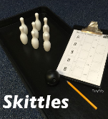

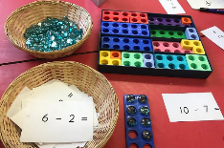
Wednesday: Play a game of skittles. Give children a score sheet to complete.

Thursday: Sing Five Spaceman (or alternative counting back song) with accompanying concrete resources.

Model subtraction using numicon pieces: take a card, find the correct starting piece, put the same number of counters on top and take away the number shown. How many left?
Friday: Sing Five Currant Buns (or alternative counting back song) with accompanying concrete resources. Give children counters and tens frames and write on board a subtraction calculation. Read it. Who can solve it?

