EYFS Enabling Environment Plan Term: 1 Week commencing: 12th October 2020
Topic: E is for Explorers (Autumn week)
Every Day:  Role Play  Construction  Outside  Including sand/water/mud kitchen | PD  (Malleable Materials/Funky Fingers) | Literacy | Mathematics | The World  (Discovery/ICT) | EMM  (Art and Music)
MONDAY | Funky Fingers: transfer the conkers to the jars using tools provided  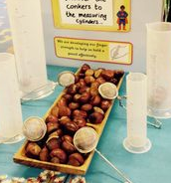  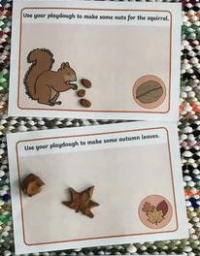  Tuff Tray: autumn playdough | 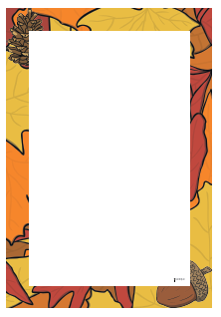  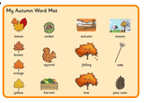  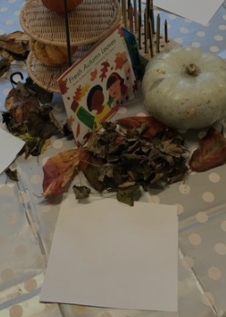  Autumn Invitation to write – use word mats and autumn paper | 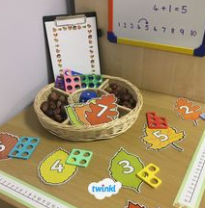  Match numicon and conkers to numbers on leaves | 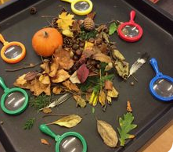  Look closely at autumn objects | 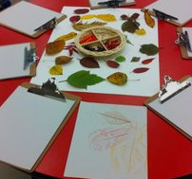  Invitation to paint autumn picture
TUESDAY | 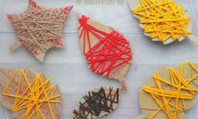  Funky Fingers: autumn leaf wrapping | Autumn Invitation to write – use word mats and autumn paper | 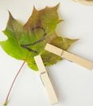  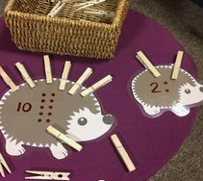  Pegs on hedgehogs (or autumn leaves) | Look closely at autumn objects | 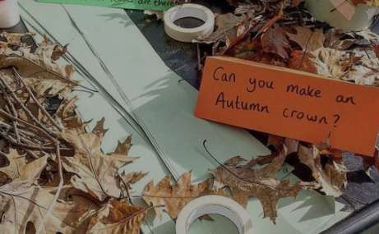  Autumn Crowns
WEDNESDAY | Funky Fingers: autumn loose parts in a frame  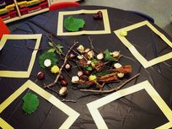  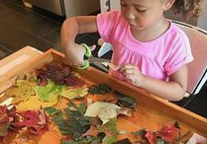  Tuff Spot: Leaf Cutting | CVC word building with laminated leaves  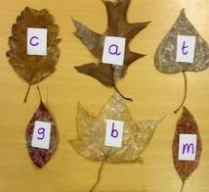 | 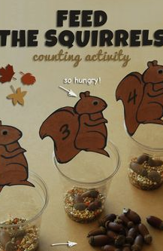  Feed the squirrels counting activity | Photos of autumn  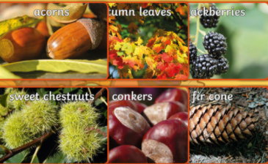 | 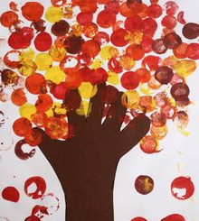  Use corks to print leaves
THURSDAY | 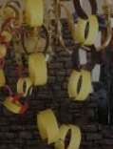  Funky Fingers: Autumn coloured paper paper chains  Tuff Spot: find the conkers  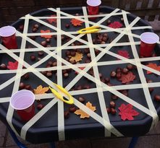 | Sight word building with autumn leaves | 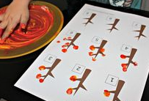  Finger paint right number of leaves on the trees | Use ipads to take photos of autumn objects collected around school/on walk. | 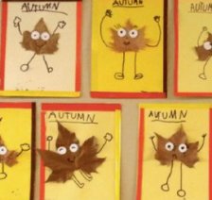  Autumn Leaf people
FRIDAY | Tuff Tray: autumn playdough | Write about Autumn leaf people made yesterday | Autumn ‘I spy and count’  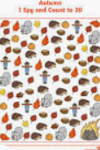 | Use ipads to take photos of autumn objects collected around school/on walk. | 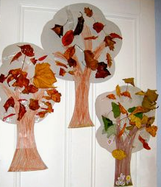  Autumn Tree collage

