EYFS Enabling Environment Plan Term: 1 Week commencing: 19th October 2020
Topic: E is for Explorers
Every Day:  Role Play  Construction  Outside  Including sand/water/mud kitchen | PD  (Malleable Materials/Funky Fingers) | Literacy | Mathematics | The World  (Discovery/ICT) | EMM  (Art and Music)
MONDAY | Funky Fingers:  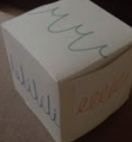  roll a die and copy the handwriting pattern  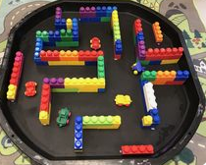  Tuff Tray: Lego Maze challenge | 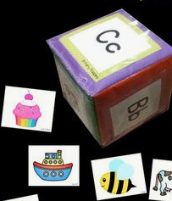  Roll and find a picture to match the sound | 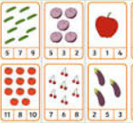  Count and peg activity | 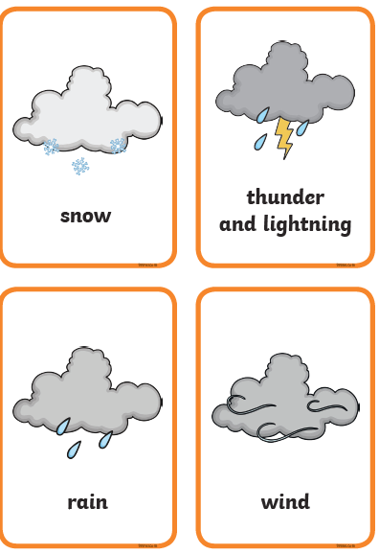  Weather Symbol cards – use with map puzzles (can they identify differences in weather around the world?) | 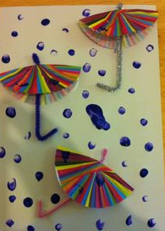  Rain and umbrella picture using cupcake cases.
TUESDAY | Funky Fingers:  Make a pattern with  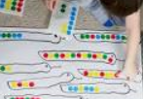  dot stickers  Tuff Tray:  Bubble dough- cornflour and washing up liquid | 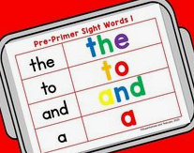  Make the sight words with magnetic letters | 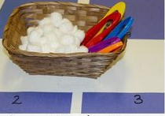  Counting snowballs activity: | Weather Symbol cards – use with map puzzles (can they identify differences in weather around the world?) | Draw/Paint weather symbols
WEDNESDAY | 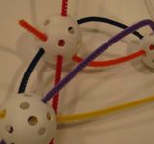  Funky Fingers: threading  Tuff Tray: | Label the weather symbols  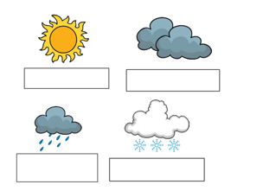 | Cut and stick numbers 1-10 (Assessment)  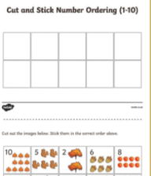 | Weather forecasting role play  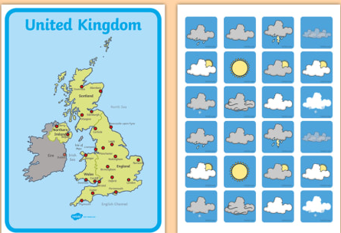 | 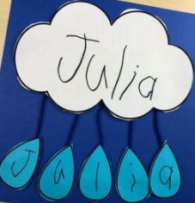  Raincloud name activity
THURSDAY | Funky Fingers: colour and cut the shapes  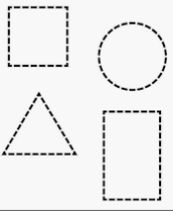  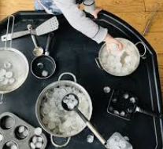  Tuff Tray: Explore the ice | 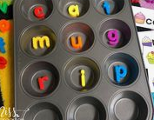  Can you make CVC words in the cake tin? | 2 D shape sorting  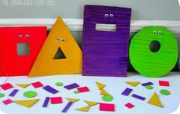 | Sort animals that live in ‘hot’ and ‘cold’ climates.  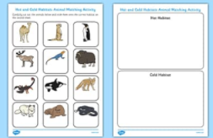  Enlarge and laminate twinkl resource as well as providing animals. | 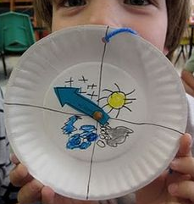  Paper plate ‘What’s the weather?’
FRIDAY | Funky Fingers: colour and cut the shapes  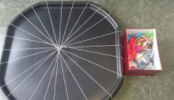  Tuff Tray: weave on the tuff tray | Phonic Game from classroom | 2 D shape sorting | Sort animals that live in ‘hot’ and ‘cold’ climates.  Enlarge and laminate twinkl resource as well as providing animals. | 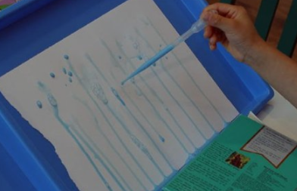  Use pipette and watery blue paint to make a rain picture – add cotton wool buds clouds?

