Exploring Arctic Explorers
Definition
Arctic explorers are people who travel to the arctic regions of the earth to find new scientific facts.

Clothing
Exploring in the arctic can get extremely cold and can even give you frostbite. Explorers have to wear special clothing to protect them. Snow goggles protect explorer’s eyes from getting sunburnt or snow blindness. They are better than sunglasses because the sun can’t peek around the sides of snow goggles like it can with sunglasses.

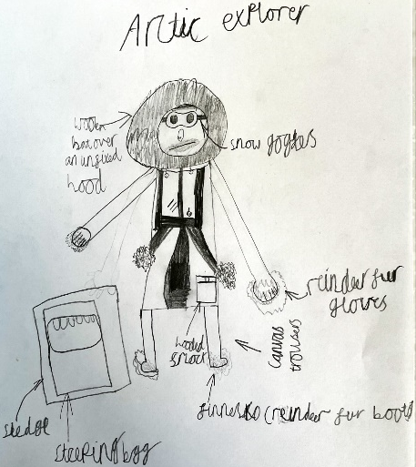
In the past explorers would have worn clothing that was made of natural materials, such as wool and fur. For example, they would wear reindeer fur boots and mittens called komargars and finnesko. These would keep the explorer’s hands and feet warm, and stopped them from getting frostbite. Explorers also wore hats made of wool. These would stay warm in the cold temperature, but if they got wet they would become cold and damp.

Modern explorers now wear clothing made from man-made materials. They wear lots of light layers rather than two or three thick layers. The outer layers are waterproof, keeping them dry and warm inside. They make sure to wear clothing that doesn’t cause them to sweat and isn’t too tight.

Habitat
Explorers would carry all their supplies and sleeping equipment in sledges that were made from wood, leather and rope. Explorers would attach the sledges to their backs, using ropes and pull them. Sometimes the sledges were pulled by animals, like dogs and ponies.

Explorers slept inside sleeping bags made from reindeer fur. When the explorers were at their base camp their sleeping bags would stay dry, but if the bags got wet during the exploration, they would become stiff and heavy to carry.

Modern explorers sleep in a sleeping bag in the shape of an Egyptian mummy, so that the material isn’t too loose. They have a three layer sleeping bag system, with a built in hood to keep their heads warm.

Food
Early explorers found that traveling through the arctic regions uses a lot of energy and the cold made them feel hungry. Arctic explorers have to have a lot of fat and calories to keep up their energy, so they can walk long distances on their journeys. Their food has to be low in water content, so that it doesn’t freeze.

In the past some of the things explorers would eat were biscuits and pemmican beef, a mixture of animal fat, meat and dried berries. Some would eat seal meat, which would be curried, fried or in made into soup. The famous explorer, Roald Amundsen ate his dogs in order to survive his exploration.

Breakfast is the most important meal of the day for arctic explorers, because it gives them lots of energy to begin their day. They need to keep their energy levels up by eating regularly throughout the day. They also have to drink lots of water to stay hydrated. They get this from melting snow in special containers.

Famous arctic explorers
- Captain Robert Falcon Scott
- Roald Amundsen
- Sir Ernest Shackleton

Conclusion
Arctic explorers need to be strong, fit and healthy to survive the extreme conditions in the polar regions. They also need to be courageous and prepared for anything. The arctic climate is cold and harsh. Explorers must protect themselves by wearing special clothes and eating high energy food.

