Day | Activity
Monday | Have a look at Yuri Gagarin. What did he do?  https://www.youtube.com/watch?v=7iMa03BApcQ  Talk to your child about what Yuri Gagarin did.  EYFS-Can you write some words about him? E.g First man in space.  Year one-If you want to extend-Model sentence Yuri Gagarin completed one orbit of Earth on 12 April 1961. He was an aerospace pilot.
Tuesday | https://www.youtube.com/watch?list=PLbyvawxScNbuGmgshrhbBrBxKwJLmM7i8&v=Z7Z-fdpfnb8 What did he do?  Talk to your child about what Tim Peake did.  EYFS-Can you write some words about him? E.g First British man on the space shuttle.  Year One-If you want to extend Tim Peake launched a Soyuz rocket on 15 December 2015 and landed back on Earth on 18 June 2016 after 186 days in space.  He was the first British ESA astronaut to visit the International Space Station.  He did many experiments in space.  Afternoon  Can you make the soyuz rocket that Tim Peake launched in?  https://www.bbc.co.uk/news/av/science-environment-35102646
Wednesday | Watch this film- https://www.youtube.com/watch?v=ASQkz4XaphU  Children to plot the correct planet names for each planet-see sheet. For extra learning can you write some facts about the planets?  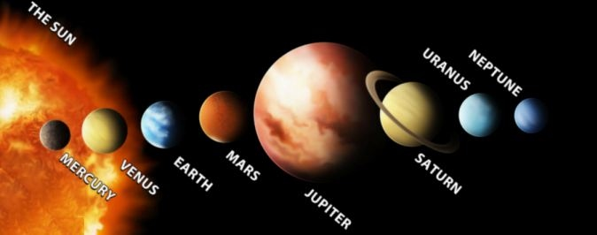  Afternoon-Children draw what is in our solar system? With paints, chalk, crayons, lego anything you might have in the house.
Thursday | Space writing sheet attached.  Can you write about each space picture? Tell your adult what you can see and then write words or sentences about what you can see and what you know about each one.

