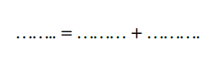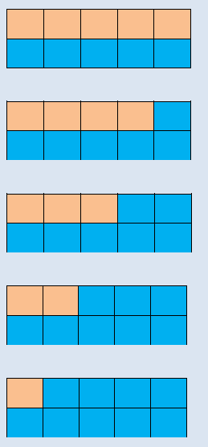

27.11.20 WALT: add more

Write the number bonds for 10:



Which number bond is missing?