EYFS/Year 1 Project Activities for Home Learning TERM 3
Please upload photos of your child doing any of these activities onto Tapestry please.
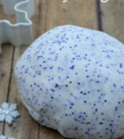  Sensory Play:  Two ingredient sparkly playdough:  ½ cup hair conditioner  1 cup cornflour  (Glitter for the sparkles!) | 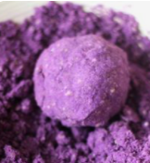  Sensory Play:  Moon Sand: 2 cups of flour and ¼ cup of oil( baby/vegetable/olive/coconut)  Food colouring optional! | 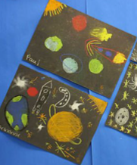  Draw with chalks on black paper
Look at some images of the moon on the internet. Make moon craters in a bowl of sand or flour or paint the moon and make craters using milk bottle tops.  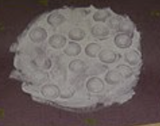  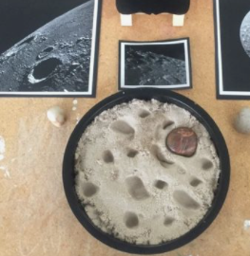 | 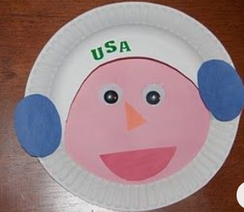  Make a paper plate astronaut. Fold paper to make an astronaut.  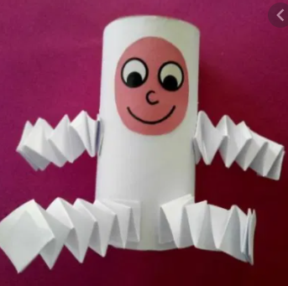 | 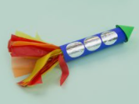  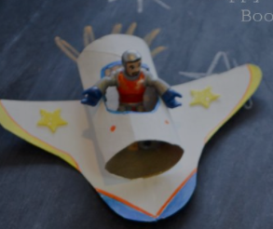  Make cardboard tube rockets or space shuttles
What can you make with just one cup of lego?  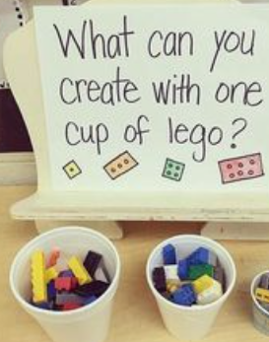 | 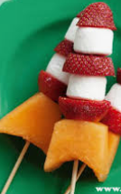  Make rocket fruit kebabs or other space themed food!  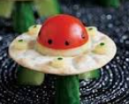  Can you find out how astronauts eat in space? | Would you rather questions???  Don’t forget to explain your choice using the word because. You can write your responses or just have a chat about them!  Would you rather explore space in a rocket or explore under the sea in a submarine?  Would you rather have only the moon in the sky at night or only the stars?
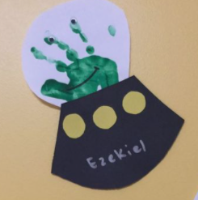  Handprint alien spaceship | Cosmic Yoga  Space themed cosmic yoga adventure:  https://www.youtube.com/watch?v=v9W8iV4AJYQ  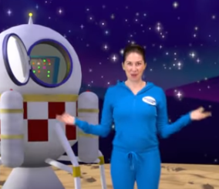 | 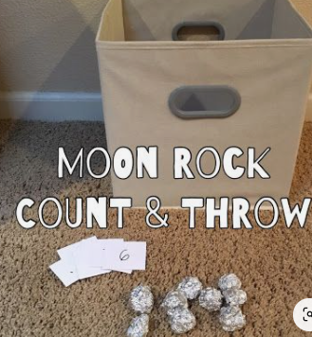  Scrunch up tin foil to make moon rocks. Roll a dice or pick numbers written on pieces of paper. Throw that number of moon rocks into a box or bowl.
Find a song online to learn about the planets  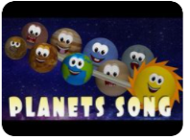 | Can you find out about our solar system? Choose one of the ways here to represent it:  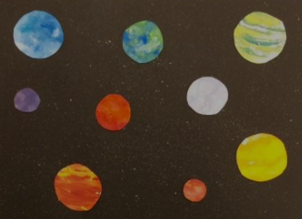  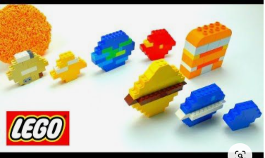  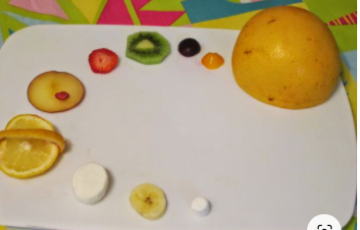  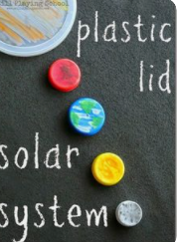  Plastic lids: Fruit: Lego: Paint:
Read ‘The Moon Game’ poem( see below)  Draw the moon on different days as it passes through its phases.  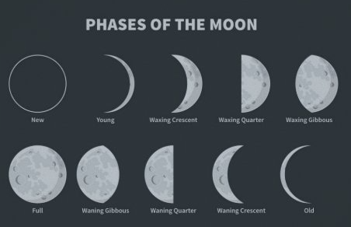 | 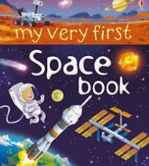  Space themed story books – look online for audio versions:  