*Pre-Measurement letter Reception*

|  |  |
| --- | --- |
| September 2024 | School Health Nursing Service  Badger House  Oldmixon Crescent  Weston-Super-Mare  North Somerset  BS24 9AY  Tel: 0300 125 6798  Email: [nsomerset.schoolnurses@nhs.net](mailto:nsomerset.schoolnurses@nhs.net) |
| This document can be provided in other formats and languages, please contact us:  Haddii aad u baahatid dukumentigan luqad kale, fadlan tag:  :إذا ﻛﻧت ﺗﺣﺗﺎج إﻟﻰ ھذا اﻟﻣﺳﺗﻧد ﺑﻠﻐﺔ أﺧرى ، ﻓﯾرﺟﻰ اﻻﻧﺗﻘﺎل إﻟﻰ:  Jeśli potrzebujesz tego dokumentu w innym języku, przejdź do: | [nsomerset.schoolnurses@nhs.net](mailto:nsomerset.schoolnurses@nhs.net) |

Dear Parent/Guardian

**Height and weight checks for children in Reception and Year 6**

Every year in England, school children in Reception and Year 6 have their height and weight checked at school as part of the National Child Measurement Programme. Height and weight measurements are used to calculate weight status. We collect this information to build a picture of how children are growing to help plan better health and leisure services for families. In most areas, parents receive their child’s measurement data as this can be useful information about their child’s growth and provides an opportunity to offer support to parents where required. Your child’s class will take part in this year’s programme.

Once the measurements have been completed, we will let you know what the measurements are in a letter which will also include information and advice to support healthy living. A member of the school nursing team may also contact you to discuss your child’s feedback and to offer further support.

**How we collect your child’s measurements**

**The checks are carried out by trained school health nursing staff in small groups for reception year and individually for year 6 pupils. Children are measured fully clothed, except for their coats and shoes.** The programme will be delivered in a safe way, in line with the school and local authority’s safety control measures and national guidance for schools and healthcare.

**Maintaining the well-being of children**

The wellbeing of children and families is very important, and measurements are taken in a sensitive way. Research is ongoing to ensure this continues to be done in a supportive way. Individual results are not shared with your child or their school. The weight and height information is shared only with you via a parent or carer feedback letter and/or telephone call. It is your choice to share or not share the information with your child.

If you are concerned about your child’s growth, weight, body image or eating patterns, please seek further support from the school nursing team on the above contact number or your doctor / General Practitioner (GP).

**The information we collect and what it is used for is listed below:**

* your child’s height, weight, date of measurement, sex and date of birth are used to calculate your child’s weight category
* your child’s name, date of birth and NHS Number are used to link your child’s measurements in Reception and Year 6. Other data sets held by NHS England and Department of Health and Social Care may also be linked to allow the addition of information from health and education records, where lawful to do so, to understand how and why the weight of children is changing, and how this affects children’s health and education and how the care children receive can be improved. This includes your child’s health data relating to;
  + their birth, hospital care (including time in hospital and out-patient appointments and diagnosis of medical conditions)
  + mental health
  + social care
  + primary care - includes all healthcare outside of hospital such as GP and dental appointments,
  + public health - including data relating to preventing ill health such as immunisation records
  + records for when and the reason people pass away
  + medical conditions such as cancer, diabetes
  + health, lifestyle, and wellbeing surveys that your child has participated in
* your child’s ethnicity and address are used to help understand some of the reasons for the difference and changes in child weight across England

**We need your email address and phone number because we may:**

* contact you by email or phone to discuss your child’s results
* send you your child’s feedback letter by email
* offer you further support following your child’s height and weight measurement

**All the data collected is also used for improving health, care and services through research and planning.**

**All this information is treated confidentially and held securely. No individual measurements will be given to school staff or other children.**

**How the data is used**

The information collected from all schools in the area will be gathered and held securely by Sirona care and health. We will store your child’s information as part of their local child health record on the NHS’s child health information database and share it with their GP.

All the information collected about your child will be sent by us to NHS England. NHS England is responsible for collecting data and information about health and care so that this can be used to monitor and improve the care provided to people across England.

The information collected about your child will also be shared by NHS England with the Office for Health Improvement and Disparities (OHID) which is part of the Department of Health and Social Care (DHSC) but in a de-personalised form only. This means OHID will not be able to identify your child.

Both NHS England and the Office for Health Improvement and Disparities (OHID) will use the information from the National Child Measurement Programme to better understand numbers and trends in child weight and body mass index (BMI). This helps with the planning of services to support healthy lifestyles in your area. No information will ever be published by NHS England or the Office for Health Improvement and Disparities (OHID) that identifies your child. NHS England use the data to produce [National Child Measurement Programme statistics reports](https://digital.nhs.uk/data-and-information/publications/statistical/national-child-measurement-programme) showing trends at national and local community level.

De-personalised information from the National Child Measurement Programme may also be shared by NHS England with other organisations, such as universities. This is to help improve health, care and services through research and planning. This information cannot be used to identify your child, and NHS England only ever shares information for research through formal assurance and approvals processes, seeking advice from experts, as necessary.

**Withdrawing your child from the National Child Measurement Programme**

If you are happy for your child to be measured, you **do not** need to do anything.

If you do not want your child’s height and weight to be measured, or your child has a medical condition that affects their height or weight, please let us know by completing the opt out form at the end of this letter and returning it to [sirona.ns.schoolhealthreview@nhs.net](mailto:sirona.ns.schoolhealthreview@nhs.net) by 22nd November 2024.

Children will not be made to take part on the day if they do not want to.

**Further information**

Further information about the National Child Measurement Programme can be found at: [https://www.nhs.uk/live-well/healthy-weight/national-child-measurement-programme](https://www.nhs.uk/live-well/healthy-weight/national-child-measurement-programme/)

Information and fun ideas to help your children stay healthy can be found at:

<https://www.nhs.uk/healthier-families/>



One way to help maintain a balanced diet and physical activity for your family is the **NHS Healthy Steps** email programme. Sign up for the 8-week Healthy Steps emails and you will be sent lots of low-cost simple tips, fun games, healthy swaps, and tasty recipes on a budget.

Scan the QR code or visit [healthysteps.uk](https://healthysteps.betterhealth-healthierfamilies.co.uk/signup/print) to sign up.

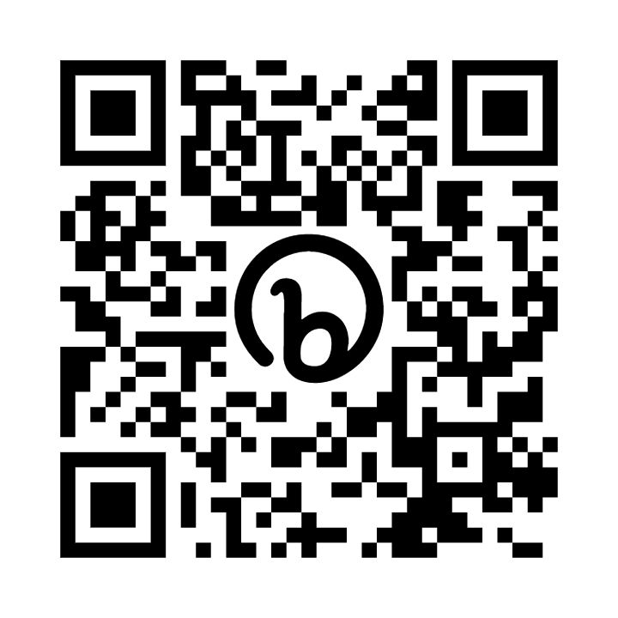

Information about how Sirona care and health collect and use information can be found at <https://communityequipment.sirona-cic.org.uk/privacy-policy/>

Information about how NHS England and Office for Health Improvement and Disparities collect and use information can be found at <https://digital.nhs.uk/about-nhs-digital/our-work/keeping-patient-data-safe/how-we-look-after-your-health-and-care-information> and <https://www.gov.uk/government/organisations/department-of-health-and-social-care/about/personal-information-charter>

Information about the organisations NHS England has shared information from the National Child Measurement Programme can be found at [https://digital.nhs.uk/services/national-child-measurement-programme](https://digital.nhs.uk/services/national-child-measurement-programme/)

Yours faithfully,

School Health Nursing Service

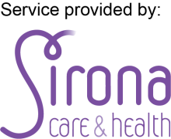Sirona care & health C.I.C is a Community Interest Company registered in England and Wales with company number 07585003. Registered office is: Sirona care & health, 2nd Floor, Kingswood Civic Centre, High Street, Kingswood, Bristol, BS15 9TR

|  |  |  |  |  |  |  |  |  |  |  |
| --- | --- | --- | --- | --- | --- | --- | --- | --- | --- | --- |
|  | **Opt-out Form**  **for National Child Measurement Programme** | | | | | | | |  | |
|  | **Only complete this form if you do not wish for your child to be weighed and measured. Please return it by 22nd November 2024.** | | | | | | | |  | |
|  | Child's Name: |  | | | Date of Birth: | |  | |  | |
|  |  |  | |  |  | |  |  | |  | |
|  | Name of School: |  | | | Ethnicity of Child: | |  | |  | |
|  |  |  | |  |  | |  |  | |  | |
|  |  |  | |  |  | |  |  | |  | |
| **I do not wish my child to take part in the National Child Measurement Programme** | | | | | | | | |  | |
| **This form must be signed by a person with parental responsibility** | | | | | | | | |  | |
|  | Signature: | |  | | | Date: |  | |  | |
|  |  |  | |  |  | |  |  | |  | |
|  | Print name: | |  | | | | | |  | |
|  |  |  | |  |  | |  |  | |  | |
|  | Relationship to child: | |  | | | | | |  | |
| We will weigh and measure your child unless you opt out by ticking the box above.  If you do not return a completed form by 22nd November 2024 your child will particate in the National Child Measurement programme.  If your child moves to a different school during the academic year, please ensure that you inform your child’s school if you do not want your child to take part.  If you have decided to opt your child out of the programme, please return this form by email to: [sirona.ns.schoolhealthreview@nhs.net](mailto:sirona.ns.schoolhealthreview@nhs.net) | | | | | | | | | | |

Sirona care & health C.I.C is a Community Interest Company registered in England and Wales with company number 07585003. Registered office is: Sirona care & health, 2nd Floor, Kingswood Civic Centre, High Street, Kingswood, Bristol, BS15 9TR