Astronauts
Definition
An astronaut is a person who is trained to travel in a spacecraft and can travel beyond the earth's atmosphere.
Clothing
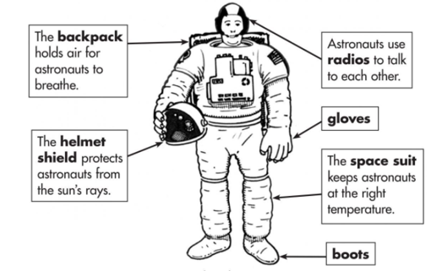
To survive in space, astronauts wear a special suit that protects their bodies from the heat and the cold. It also provides them with air to breathe. Space suits are pressurised, which means that they are full of air to support the astronaut’s body and to allow them to breathe. As a result, the suits look puffy in appearance.
A space suit is like a tiny space ship for one. It is more than just a piece of clothing! It is a very complicated machine, with air conditioning, heating, air to breathe and water to drink. It even has a built in toilet!
Some space suits attach to a rocket powered backpack, which allows the astronaut wearing it to fly around in space.

Habitat:
Most astronauts can be found living on board the International Space Station. The International Space Station is a large aircraft which orbits the Earth. The space station is also a unique science laboratory. Several nations worked together to build and use the space station. The space station is made of parts that were assembled in space by astronauts. It orbits Earth every 90 minutes. The International Space Station is home to 3-9 astronauts at a time.
Feeding habits:
Astronauts eat three meals a day: breakfast, lunch and dinner. Nutritionists ensure the food astronauts eat provides them with a balanced supply of vitamins and minerals. Calorie requirements differ for astronauts. For instance, a small woman would require only about 1,900 calories a day, while a large man would require about 3,200 calories. An astronaut can choose from many types of foods such as fruits, nuts, peanut butter, chicken, beef, seafood, candy, brownies, etc. Available drinks include coffee, tea, orange juice, fruit punches and lemonade.
As on Earth, space food comes in disposable packages. Astronauts must throw their packages away when they have finished eating. Some packaging actually prevents food from flying away. The food packaging is designed to be flexible and easier to use, as well as to maximize space when stowing or disposing of food containers.
Famous Astronauts
- Tim Peake
Conclusion:
The best astronauts are intelligent, adaptable and physically fit. They are comfortable working in confined spaces and being away from home.

