Monday 25th January
WALT: describe the properties of different rocks

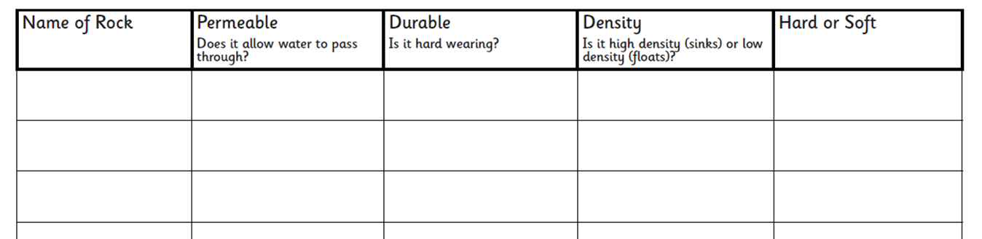
Task – Complete the grid by using the internet or fact cards to find properties of 3 different rocks.

Extension activity: Can you match the name of the rock with the correct rock group? For example: Brick = human made.

Rock 1 –
Rock 2 –
Rock 3 -

