Activity 2

12.11.20 WALT: add

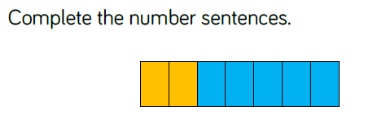

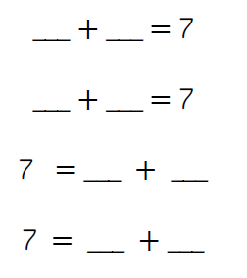

Challenge:

Complete part/part/whole model using three numbers:

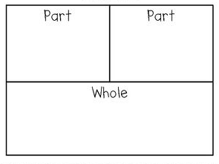

Write the four number sentences: