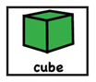
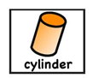
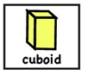
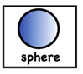
Activity Sheet 1 Day 2
I have 1 curved face.
I have 0 corners/vertexes.
I am easy to roll.
I have 6 faces that are all square.
I have 6 corners.
I have 12 straight edges.
I have 6 faces.
I have 6 corners
I have 12 straight edges.

I have 2 circle faces.
I have 1 curved face.
I have no corners/vertexes
I have 2 curved edges.
7.01.21

