EYFS Enabling Environment Plan Term: 2 Week commencing: 2nd November 2020
Topic: E is for Explorers
Every Day:  Role Play  Outside  Including sand/water/mud kitchen | PD  (Malleable Materials/Funky Fingers) | Literacy | Mathematics | The World  (Discovery/ICT) | EMM  (Art and Music)
MONDAY | 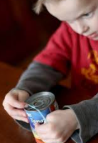  Cover the tin with elastic bands  Tuff Tray: explore a pumpkin  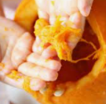 | Katie Morag story S laminated pictures to order  Phonic activity from classroom | Pumpkin seed counting  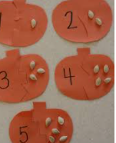 | Mirrors and symmetry patterns.  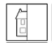 | Bottle cap pumpkins  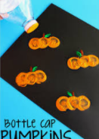  Year 1 art; paint experiment with a variety of tools.
TUESDAY | Funky Fingers:  cutting skills  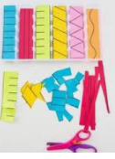  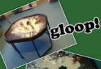  Tuff Tray:  Play dough/ Gloop | Katie Morag story S laminated pictures to order | 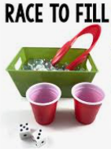  Race to fill game | 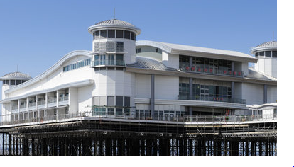  Pictures of Weston pier old and new | Draw the other half pictures  Year 1 art drawing: Identify lines and shpes . understand lines go in different ways
WEDNESDAY | Funky Fingers:  Threading activety  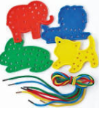  Tuff Tray:  Small World : Dolls House/Fire Station/ Farm | Phonic game/sight word rainbow writing  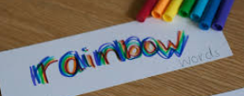 | Who has more game?  One child is yellow, one is red. When tens frame filled who had more/less?  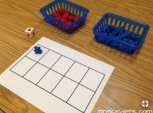 | Pictures of Weston pier old and new | 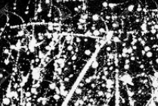  Starry sky painting: use thin brushes to flick white/yellow paint on black paper  Year 1 Art: paint lines.
THURSDAY | Funky Fingers: pipe cleaner firework can  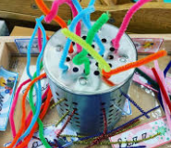  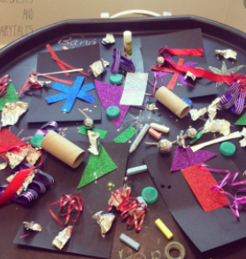  Tuff Tray : invitation to make fireworks  Year 1 art; Replicate shapes. Manipulate materials. Build using construction / sculpture. | 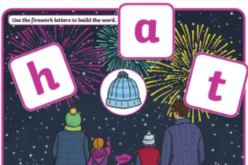  CVC word building with magnetic letters | 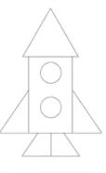  Firework shapes – can you make a firework rocket using the shapes? | Firework Display Pictures  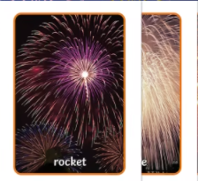 | Firework Art use toilet rolls cut  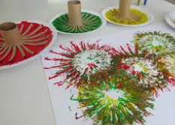  Year 1 At: Experiment with tools.
FRIDAY | 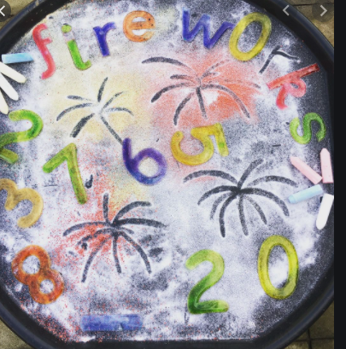  Tuff Tray: glitter in the tray/finger printing  Funky Fingers: Copy the lego patterns  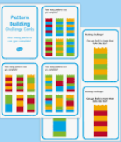 | Bonfire night writing  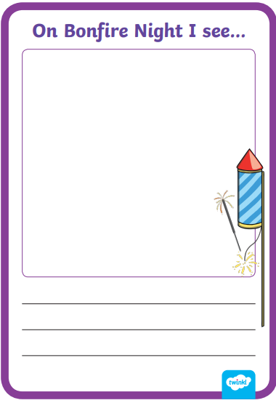 | 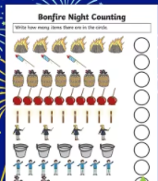  Bonfire night counting sheet | Firework Display pictures | 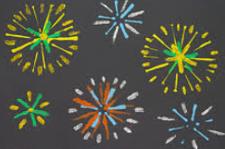  Firework Art – use fingers or cotton buds  Year 1 At: Experiment with tools.

