EYFS Enabling Environment Plan Term: 2 Week commencing: 9th November 2020
Topic: E is for Explorers (DIVALI 14th November Remembrance Day 11th November)
Every Day:  Role Play  Outside  Including sand/water/mud kitchen | PD  (inc. Malleable Materials/Sensory Play} | PD: Funky Fingers | Literacy | Mathematics | The World  (Discovery/ICT) | EMM  (Art and Music)
MONDAY | Make a domino run on the Tuff Spot  Year 1 DT Structure,  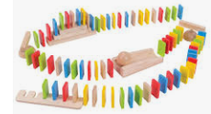 | How quickly can you do up buttons on a cardigan?  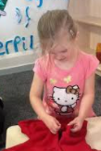 | Phonic Game from classroom :  Roll a sound SATPIN?  CVC word building | Hole punch counting activity ( 5- 15)   | Ipads – topmarks maths games(use timers to regulate use) | Musical Instruments/ Sing It Rhyme bag  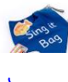
TUESDAY | Cutting skills  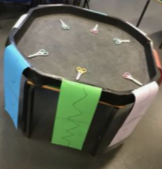 | Transferring marbles using different tools(Spoon, tong, tea strainer, fork)  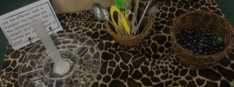 | Writing under a table – pick a sight word card to copy  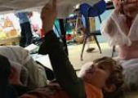 | Counting pennies to match an amount / How many can you stack in a tower?   | Exploring mirrors | Use eye stickers as a prompt to draw. Stick onto blank pieces of paper – what will they create?    Year 1 art Collage – attach materials to create a picture.
WEDNESDAY | 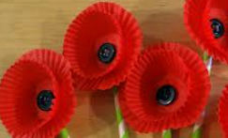  Tuff Spot: making poppies with cupcake cases/tissue paper?  Year 1 art – college. | 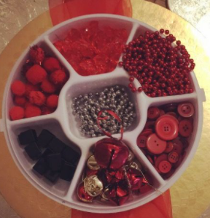  Make a poppy with black and red loose parts  Year 1 art: Select colours for attended purposes. | Sight word Dab  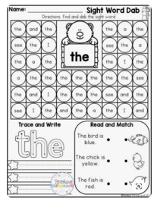 | 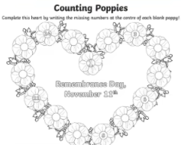  Poppy counting sheet and counting real poppies | Remembrance Day Photos/ Poppies/Poppy Cross | 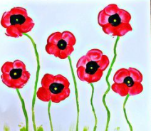  Fingerprint Poppies  Year 1 : Year 1 pattern.
THURSDAY | Tuff Spot: Divali Playdough Mats  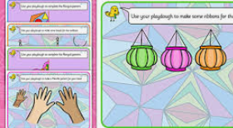 | 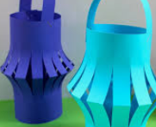  Divali Lanterns  Year 1 college 3d | Sight word making with magnetic letters  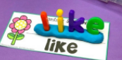 | 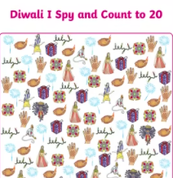  Divali I spy and count to 20 | Divali colouring sheets | 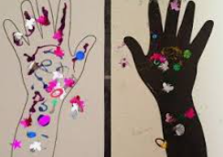  Divali Hand art  Year 1 – college.
FRIDAY | Tuff Spot:  Coloured rice Rangoli patterns | Divali Lanterns  As above. | Use washing lines to create a blending line:  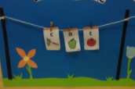 | Divali I spy and count to 20 | Divali photos | Divali Lights Art  