Term 2, Week 5- Date: 30.11.20
Focus for the week:
- Teach reading and spelling of a-e i-e o-e
- Teach reading and spelling of sight words Mr, Mrs and recap sight words people, their, your, here
 | Monday | Tuesday | Wednesday | Thursday | Friday
Revisit/ Review | Go through phase 5 flashcards sounds- ay, ou, ie, ea, oy, ir, ue, aw, wh, ph, ew, oe, au, y | Show flashcard for a-e. Can you think of any a-e sound words? Write them on board together. | Go through phase 5 flashcards. Can you tell your partner a word with the a-e sound and a word with the o-e sound? | Can you write a word with each sound (a-e, i-e, o-e)? | Go through all phase 5 flashcards sounds learnt
Teach | Explain split digraphs.  using the a-e sound.  4 children to hold a sound. The children with the ‘a’ and ‘e’ sounds hold hands over the child in the middle. Explain that they are friends and go together. | Introduce o-e sound.  Repeat- 4 children to hold a sound. The children with the ‘i’ and ‘e’ sounds hold hands. They are friends and go together. | Introduce i-e sound.  Repeat- 4 children to hold a sound. The children with the ‘i’ and ‘e’ sounds hold hands. They are friends and go together. | Have two children stand up to make the split digraph.  Give all other children a card with different graphemes.  Children to make different words by standing in between them. | Sight word splat-  Sight word cards on the floor or words written on the board. Children to splat the word you say.  (Mr, Mrs, people, their, your, here)
Practice | Display with sound buttons a-e sound words.  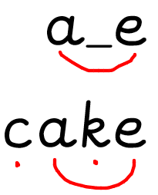  Read with sound buttons a-e sound words.  cake, made, shake, snake, name, flame, late, lane, take, flake, blame, tape | Read with sound buttons o-e sound words.  cone, mode, rose, phone, home, alone, note, stroke, stone, those, spoke  Challenge- envelope  Read sentence together- Can I phone home? | Read with sound buttons i-e sound words.  fine, rise, whine, line, strike, spike, bike, white, dislike, fine, inside, time, quite  Read sentence together-  White spikes on the bike | Children to write a sentence with one of the words they have written down.  Challenge- can you write a sentence using all three split diagraphs we’ve learnt. | Have different split digraphs on coat hanger clips. Children to work in groups to see what words they can make.  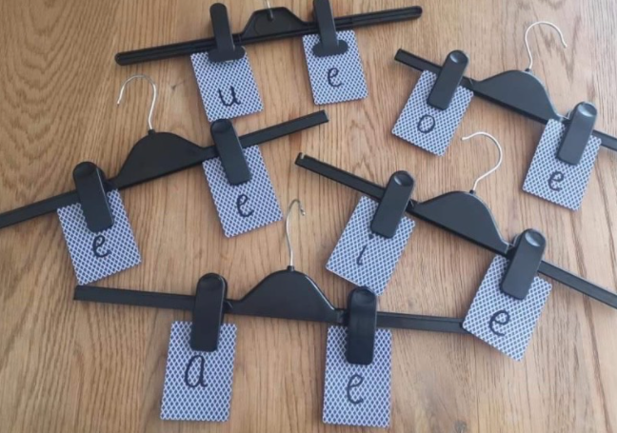
Apply | Ask children to write a-e sound words with sound buttons. | Outside with chalk, write o-e sound words. | Use magnetic letters to make different i-e sound words. Use different colours if possible- e.g…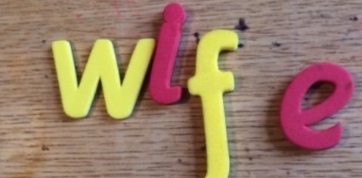 | Play buried treasure on phonics play- a_e, o_e and i_e sound.
Assessment:
- Can orally blend & segment words with (a-e, o-e, i-e).
- Can blend & segment in order to read and spell
.

