Term 2, Week 6- Date: 7.12.20
Focus for the week:
- Teach reading and spelling of e-e, u-e
- Teach reading and spelling of sight words Mr, Mrs, people, their, your, here
 | Monday | Tuesday | Wednesday | Thursday | Friday
Revisit/ Review | Go through phase 5 flashcards sounds | Show flashcard for u-e. Can you think of any u-e sound words? Write them on board together. | Go through all phase 5 flashcards. | Go through flash cards and read this week’s sight words altogether. | Go through all phase 5 flashcards sounds learnt
Teach | Recap split digraphs. Teach the u-e sound.  What u-e sounds do we already know?  4 children to hold a sound. The children with the ‘i’ and ‘e’ sounds hold hands, they are friends and make the i-e sound together. | Introduce e-e sound.  Repeat- 4 children to hold a sound. The children with the ‘e’ sounds hold hands. They are friends and go together. | Show the children the pictures containing each split digraph, children to write what they see.  (Pictures on home learning powerpoint). | Write all split diagraphs on the board.  Can you tell your partner a word with each sound? Take it in turns. | Go through each sight word- Mr Mrs Your, Here, Their, People  Spell each one building up the letters in each word.
Practice | Display with sound buttons i-e sound words. Read altogether.  cube, cute, tune, fuse, mute, flute, huge, use, fume  Challenge- | Read with sound buttons e-e sound words.  Pete, even, delete, complete, these, concrete, extreme, theme, athlete  Read sentence together- Pete is an extreme athlete.  Children to write a few e-e sound words. | Watch Alphablocks ‘Magic e song’ again from yesterday.  Children to see how many words they can remember. Share with a partner and then write them down. | Have different split digraphs on coat hanger clips. Children to work in groups to see what words they can make.  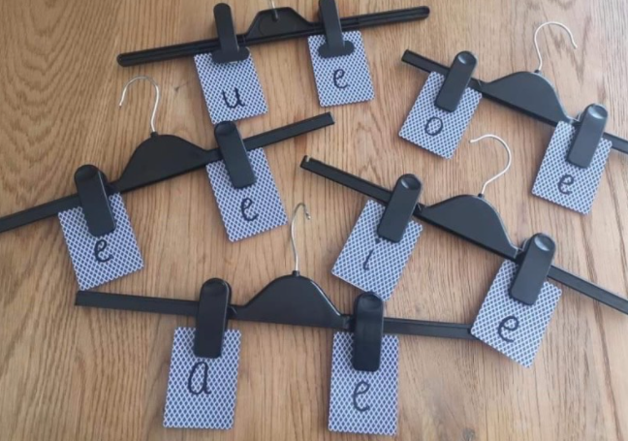 | Finding split digraphs.  Have a piece of A3 paper for each sound written at the top.  Children to look through catalogues/newspaper to find split digraphs. Then cut the word out and stick them on the right paper.  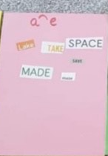
Apply | On a roll of paper on the floor, children to wite as many u-e sound words as they can. | Alphablocks ‘Magic e song’  https://www.youtube.com/watch?v=  Q_ocI6r_N-c | Can you use one of those words to create your own sentence? | Dragons den on phonics play. Play with each split diagraph.
Assessment:
- Can orally blend & segment words with (e-e, u-e).
- Can blend & segment in order to read and spell

