English- introduction to space, questions
Maths- recognise, name and sort 3D shapes
Day | Focus/ Objective/ Success Criteria | Activity | EYFS adult lead | Evaluation of Learning / What next for Teaching & Learning?
Session 1-h | WALT discuss | TUESDAY  Starter- introduce plurals by adding s. Show some examples- ‘pen’ becomes ‘pens’. Show more examples- dog, sweet, chair, boy, girl.  https://www.youtube.com/watch?v=XBPjVzSoepo  watch this video.  What do you think happens in space? Think, pair, jot white boards.  Pull class back together-what would you like to learn about space?  Model question starts who, what, where, why, do, can questions. Write a couple on the board.  AL-Write on question marks-photocopy some to go on the board.  - Exit ticket to be written about what they know about space.  Afternoon-guided reading/PSHE/PE | Writing – What did you get for Christmas.  - Picture and initial sound.  - Words  - Sentence I got a …  Join in wed pm task – record responses on tapestry. | 15 minute WALT add and subtract  Tuesday :  Count form 88 back to 62.  Count in tens, count in twos.  What is worng in sequence?  10, 20, 30, 40 15.  2, 4, 6, 8, 9.  Wednesday:  Count backwards from 50. Repeat if necessary.  Solve calculations on board, draw part/part/whole models for each.  Thursday: WALT: add and subtract  Count backwards from 50.  Use ‘Pick a pair’ problem on SMART  Friday WALT :add  Complete ‘Bean bag’ problem on SMART. Even better if have 3 beanbags and buckets labelled 1,2,3,4
Session 2-English | WALT discuss | WEDNESDAY – English  Starter-Recap plurals. Can you think of your own examples? Think, pair, share.  https://www.youtube.com/watch?v=VE76Qc6HoUc watch the video.  What is it like to be an astronaut?  Model ideas onto enlarged astronaut.  AL-children to write their ideas.  I-can children draw what an astronaut looks like to them?  Afternoon-RE  Below-maybe groups of children could pick a different area? Two for year one and two for FS? Thermometers in the science cupboard. Tapestry observations-observing over time. Will repeat every week.  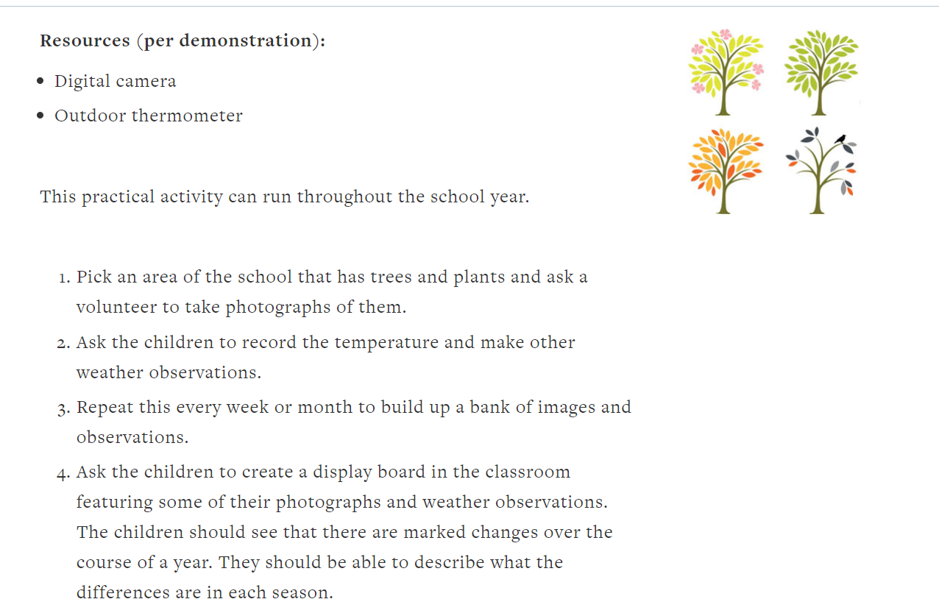
 | WALT: recognise and name 3D shapes | WEDNESDAY - Maths  Powerpoint on naming 3D shapes  Q. What is a 3D shape?  Q. Is a circle a 3D shape?  Q. Can we see any 3D shapes in the classroom?  Q. How many 3D shapes do you know?  Activity : Complete Lesson 1 sheet.  Plenary: Q on smart. . Is a pyramid only a pyramid when its point is on top?  Afternoon-
Session 3- | WALT: recognise and name 3D shapes | THURSDAY  Show children 3D shapes, ask them to name them and describe properties using words face, edge, curved, straight, vertex  Put a 3D shape in a feely bag, describe it for children, can they guess what shape it is?  Ask children to describe shape they can feel in the bag, can rest guess the shape?  Use SMART Q. What do you think the partly hidden shape is?  Activity: Lesson 2 sheet read descriptions of shapes and find the shapes that match description. Can be done as a worksheet or using real shapes.  Write a description for a pyramid or cone. |  | Greater depth : Friday lesson included.
Session 2 Mathematics | WALT: recognise and name 3D shapes | 3d shape powerpoint.  Look at SMART, Q. Have shapes been sorted correctly? Explain how you know? How else could they be sorted?(colour)  On SMART, how many ways can you sort the 4 shapes? Have a real cylinder, cone, cuboid and cube available.  Activity: Lesson 3 sheet( includes GD from Classroom Secrets)  Provision: Sort shapes using TWINKL activity.

