Year 1 Maths 18.1.20
There will be a memo on Tapestry each day with a short video clip to accompany these activities. Please upload photos of your child completing any of the activities. Thank you!

Monday | Build a model out of 3D shapes, ash children to name and describe the shapes you have used. You can use any objects in your house – toothpaste box for cuboid, ball for a sphere etc.  Show a picture using 2D shapes, name the shapes used.  Use feely bag to describe a shape in a bag, what can it be?
Tuesday | Count backwards from 100- 50.  Use sequences on SMART. (Slides 1 and 2 )  Q. What is the next three numbers?  Q. What three numbers came before?  Write sequence of numbers with a mistake.  Q. What is the mistake? How do you know?
Wednesday | Write numbers 10-19 on the board.  Say the numbers out loud.  Q. What do you notice about the sounds of the numbers?  Q. Do you notice a pattern? Are the numbers getting one bigger?  Activity: counting sheet
Thursday | Write on the board or use SMART (Slides 3 and 4) to show:  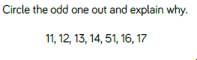  Powerpoint video. (See tapestry)  Use / print or draw two blank ten frames and use pasta as counters.  Ask them to show you different numbers( 10-19)  On your ten frames show me a number:  - more than 12  - less than 18  Show children number words for 11-19 on flashcards, then ask class to make that number up on ten frames.  Activity: worksheet
Firday | On SMART: (Slides 5-7)  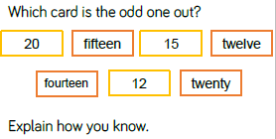  Powerpoint video. (See tapestry)  Introduce base 10 using part/part/whole models (ensure you have shown children the ‘stick’ is made up of ten pieces)  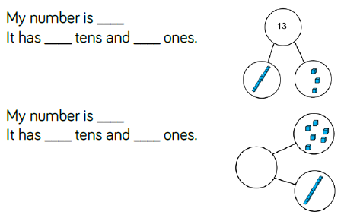  Give out base 10 and ask children to show different numbers.  Activity : Activity sheet.  In the part session: children can simply draw a stick and a dot to represent a ten block and a one.  End the lesson by answering the reasoning question on the smart.

