English-Phonic assessment
Maths- Ordinal numbers. Numberline
Day | Focus/ Objective/ Success Criteria | Activity |  | Evaluation of Learning / What next for Teaching & Learning?
Monday |  | Retrieval task:  Whole 15 year 1 children – What have you learnt so far about Uphill? What features do you know? What are physical and human features? (Use loops wall)  Record as learning story to go in geography session of learning diaries.  PHONICS ASSESSMENTS EYFS AND YEAR 1. | In afternoon-EYFS: Phonic assessments. | Maths greater depth activity – see sheet for the week.  15 minute Maths  Monday: WALT: recognise even numbers  Display 7 sweets or have 7 sweets.  Q. Can I share these sweets between Isacc and Beth?  Q. Is it fair that Beth has more?  Q. Can anyone think of a number that could be shared fairly and equally?  Check answers given.  Look at numicon pieces on board. Give out numicon pieces to each pair(1-10)  Protocol: Think Pair Share  Q. With your partner can you identify the numicon pieces that are fair?  On board make two sets of numicon pieces, introduce vocab odd and even. Q. What do you notice about the shape of the odd pieces?  Display a 0-10 numberline. Ask children to circle the even numbers.  Tuesday WALT count one less  Display 0-20 numberline on board.  Count backwards from 20. Repeat if necessary.  Point to a number; ask children what is one less. Repeat.  Write a selection of calculations on the board for children to copy and answer on whiteboards e.g. 5 – 1=, 8-1=, 10-1=  Wednesday: WALT; use a numberline  On SMART:  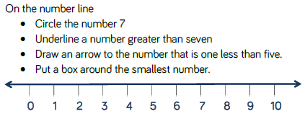  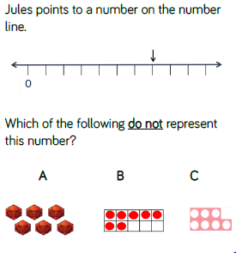
Tuesday | WALT: Ordinal numbers | Powerpoint or as below:  Q. When would I use first?  Write on board 1st and first as children explain.  Ask 10 children to make a line. Label them 1st, 2nd etc……  Q. Who is 7th?  Q. Who is last?  Q. What is date today? What does that mean?  Display beads on SMART:    Q. What colour is first bead?  Q. Which bead is 5th?  Group 1 (AL) Activity Sheet 1  Group 2 (I) Outside classroom : Children organise hop race, jump race etc. Who was first? Second? Third? Children discuss.  Group 3: Reasoning Activity( supported) Activity Sheet 2 or have threading out – thread on your bead and discuss what colour you have first, second, third etc.
Wednesday | WALT: Use a numberline. | Powerpoint  Group 1 (AL) Number line activity sheet.  Group 2 : Roll a dice –place counter on rolled number on number line. How many jumps to 10/0? Repeat.  Group 3: work with a partner. Roll dice, double the number and collect that number of cubes. Make towers. Who has most cubes after 3 turns each?
 | Inset Day
 | Inset Day

