English-Katie Morag book-likes/dislikes grid, story retell using story s, settings
Maths- Partitioning / part /-part – whole.

Day | Focus/ Objective/ Success Criteria | Activity |  | Evaluation of Learning / What next for Teaching & Learning?
Monday | English-WALT describe | https://www.youtube.com/watch?v=A1q-2g1c6HY-online version of the book-Katie Morag and the New Pier.  Read the book Katie Morag stopping at certain bits and discuss what is happening. Once finished the book- Protocol-Carousel in groups-likes, dislike, puzzle and connections on big sheets. Children to go around in small groups writing their ideas. Have a timer of 3-5mins and rotate. Children can tick ideas of other children. Once completed model the write up on flip chart.  Group 1 (AL)- children to write up the grids.  Group 2 (I) Children to draw a picture of the new Pier. Can they write a sentence about it?  Group 3-Rainbow sentences.  Afternoon-PE/GR and PSHE | In the provision-firework (bonfire night) on Thursday. Starry night story to share with resources-talk and record for Tapestry how things have changed to life in the present? Year 1-History  In afternoon-EYFS: compare and describe the Piers Weston Pier-what is the same and what is different?  In their books can they draw a story s and draw pictures to retell the story. | 15 minute Maths  Use Counting to 100 powerpoint. Count from 0-50 Children to count with the screen. Pause randomly Q. What number will come next?  Write a sequence on board, e.g. 32, 33, 34, 36, 37, 38  Q. What is the mistake? Explain why using because.  Repeat with a counting back sequence: 20, 19, 18, 16, 15, 14  Tuesday WALT double  Use Counting to 100 powerpoint. Count from 19 to 30, count back from 30 to 20.  Remind children we need to know doubles by heart.  Use fingers on two hands to show double facts 1+1, 2+2, 3+3, 4+4, 5+5  Roll dice on board. Children double number rolled.  Give out dominoes, children find double dominoes. Complete dominoes on SMART  Wednesday: WALT; count  Use 100 square powerpoint. Count from 30-50, count back from 40-0. Splat numbers as you count.  Q. Who can splat number 39?  Q. Who can splat a number less than 40?  Q. Who can splat a number more than 50?  Q. Who can splat the number one more than 22?  Q. Who can splat double 6? Etc…….  Thursday: WALT: count one more/one less  Use Counting to 100 powerpoint. Count from 0-50. Count back from 30-0.  Display 100 square powerpoint. Splat a number.  Q. What is one more than this number?  Q. What is one less?  Repeat.  Friday WALT :order  Use ICT games caterpillar ordering game. Children then have a set of numbers to put in order on the screen.  Q. Which is the smallest number? How do you know? Who can prove it using a resource?  Q. Which is the largest? Explain how you know.  Q. Who can use the language less than to describe a pair of the numbers?  Repeat.  Greater depth:  BONDS TO 6, 7, 8, 9.
Tuesday | WALT describe | To be a good author, which we will be next week when we retell the story of Katie Morag we have to be good at describing. When we describe it paints a picture in your mind. Describe a storm and get the children to close their eyes, play some storming music but don’t let them see the picture. “In the distance the waves are crashing down. The wind is howling like a cat. I can hear boats crashing into each other.” Ask the children what they thought I was describing? Show them the pictures of the settings PP. Protocol-Interactive word wall- children to add to word wall/drawing objects, pictures with words to help writing the story.  We are going to describe one of these today. Model on the board. The wind is howling. In the distance I can see waves crashing onto the rocks.  AL-Children to pick their own picture and describe. Use the sentence openers to help children. For the LA children write the sentence starters for them.  I-using water colours-can children paint a quality painting of the stormy day-see pictures as a stimulus.  I-on ipads-doodle (I think) children to create their own stormy setting. Show them how to add images on this app.  In afternoon-  Display the pictures of Weston Pier and the New Pier (show from book). Talk about the similarities and differences-record for Tapestry. Ask the children to draw Weston Pier and the Pier in the book. Can they write a sentence about the changes?
Wednesday | WALT retell | Explain to the children before we become authors next week we need to be able to retell the story. Have an s displayed on the floor-use masking tape. Go through the story retelling it on the ground. Use the words and the pictures to encourage story language. Take a picture and put on the board so children have a visual prompt as independent group doing it on the carpet.  AL-Children to do their own retell of Katie Morag. Take pictures and put in speaking and listening on Tapestry.  I-story retell using boxes to retell the story.  I-children to retell the story using the story s.  In afternoon-  Children to look at the weather in Struay and compare to the weather in Weston. Like the Pier sheet complete for weather-put in Tapestry-science.
 | WALT; Partition | Introduce part/part/whole model using powerpint.  Then on Smart:  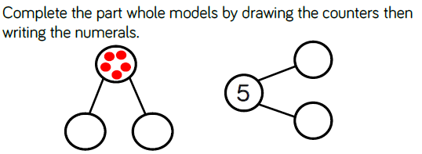  Q.Which number is the whole?  Q. Which numbers are the parts?  Q. Have we found all the possibilities?  Complete the part/part whole model for fruit on the SMART.  Group 1 AL - complete part/part whole models where 6 is the whole- children can use counters to support on top part of sheet before recording numbers. Activity Sheet 1  Group 2 (I) T:\2) Curriculum\1) Subject folders\2) Maths\Smart board template resources – year 1 – interactive part part whole for children to use as a group. Pages 1 – 6  Group 3: Find the pairs of numicon pieces that total 10. Give each child a 10 piece as a base.  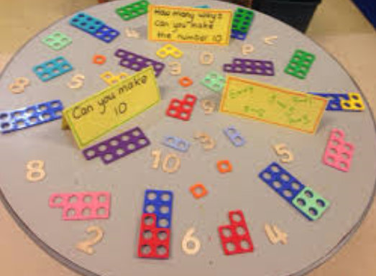
 | WALT: Partition | Powerpoint ; part/ whole.  Group 1 (AL) Remind children of the activity using numicon yesterday. Can they find the pieces that total 10 again and record part/part whole models for 10.  Group 2 (I) Activity Sheet 2  Group 3: Find dominoes that total 6

