English –writing up our report.
Maths-

Day | Focus/ Objective/ Success Criteria | Activity |  | Evaluation of Learning / What next for Teaching & Learning?
Monday | English-WALT plan | Today we are going to begin to draft our report on the four nations.  Show them your modelled version on the IWB.  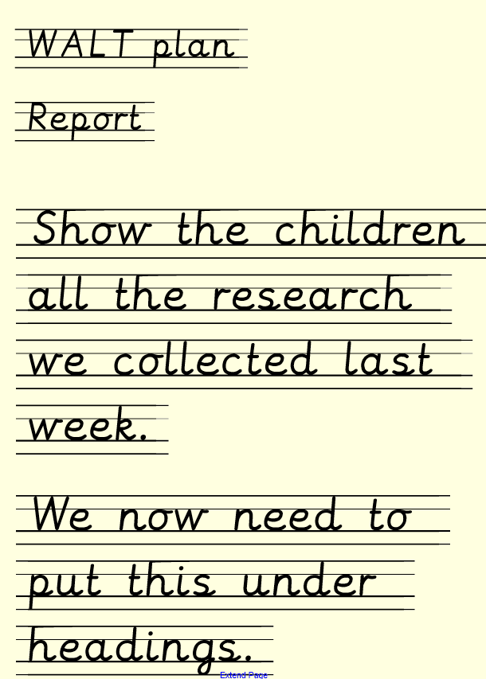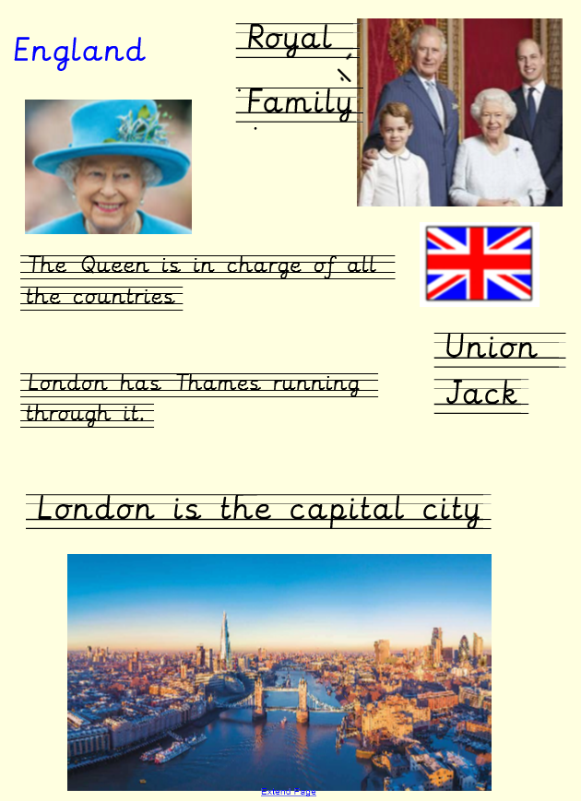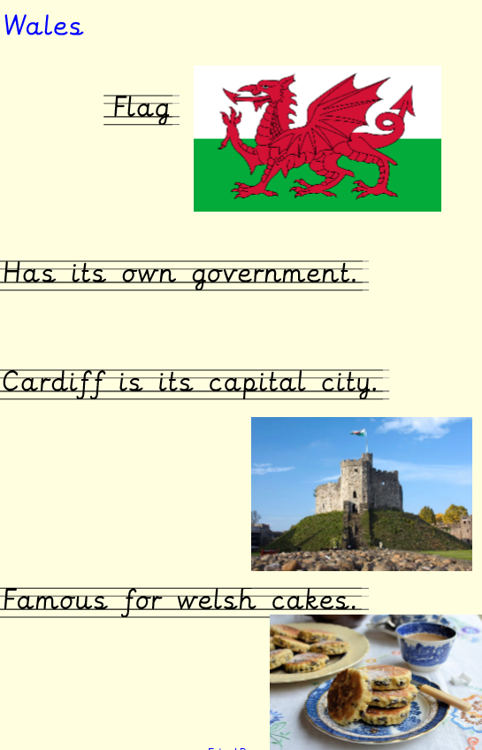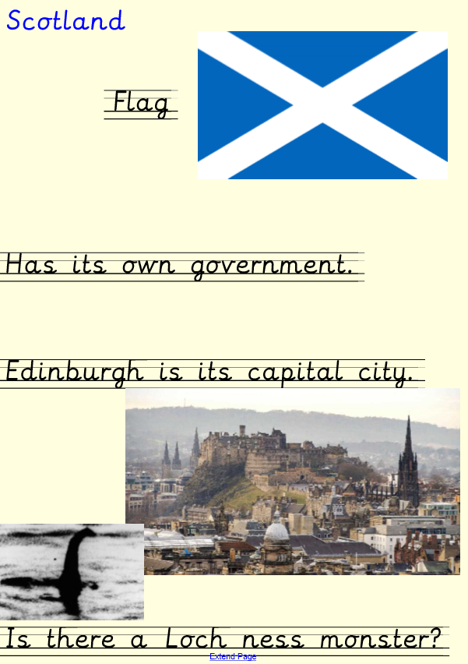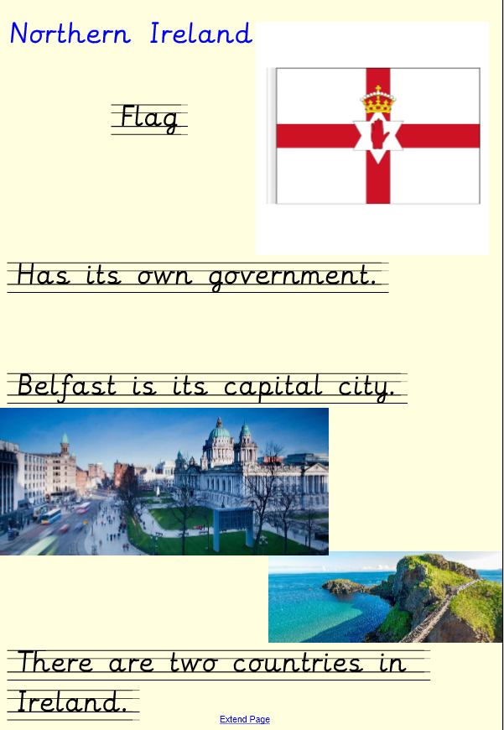  Group 1 (AL)- children to write up plan of Four nations.  Group 2 (I) https://www.jasonhawkes.com/Galleries/London/1  Show children this birds eye view. Can children make some of the buildings?  Group 3-colour in the four nations flag picture.  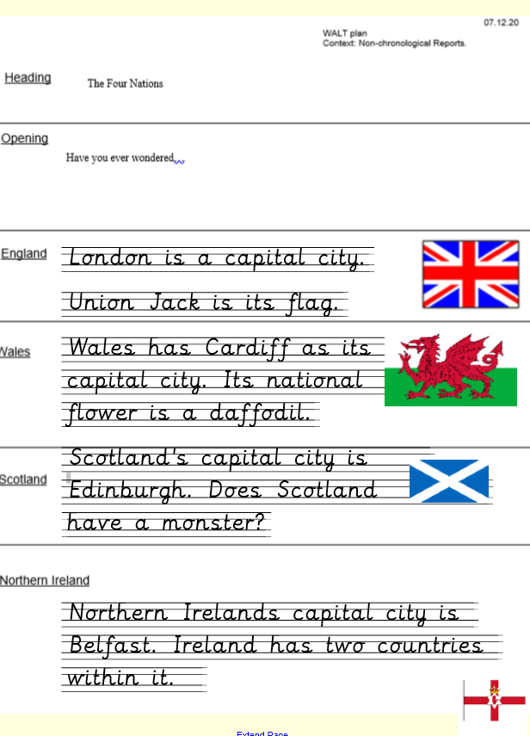  Protocol-Take a stand- have two words strongly agree/strongly disagree. Whilst reading a book-does England or Uphill have the best weather? Discuss.  Afternoon-PE/GR and PSHE | In afternoon- children to use the four nations colour sheet to write words to describe the country. | 15 minute  Monday: WALT: find a part  Solve problems on SMART (3 slides)  Tuesday WALT count  Count backwards from 50. Repeat if necessary.  Use sequences on SMART.  Q. What is the next three numbers?  Q. What three numbers came before?  Write sequence of numbers with a mistake.  Q. What is the mistake? How do you know?  Wednesday:  Odd / even numbers.  Use numberline 0 – 20 .  Which numbers are odd/ even? How do you know? Use gloves pictures with 2s on.  Coutn in twos as a class ordering gloves to 20.  Thursday: WALT; count one more/one less  Count forwards from 75-100  Count backwards from 100- 80  Use number cards 0-10, pick one from a bag, children write the number that is one more on a whiteboard.  Model writing as a number sentence: 3 + 1=4. Encourage children to do the same. Repeat for one less  Friday WALT :order  Use Maths Pack 2 Order (KS1) Choose Y1 objectives. Children then have a set of numbers to put in order on the screen.  Q. Which is the smallest number? How do you know? Who can prove it using a resource?  Q. Which is the largest? Explain how you know.  Q. Who can use the language less than to describe a pair of the numbers?  Repeat.  Maths greater depth activity – see sheet for the week.
Tuesday | WALT identify features and draft  WALT discuss | Show modelled version on the board. Show children the rubrics alongside the modelled version. Have I got these aspects? I want to make it the best version I can. Protocol-jigzaw- have modelled version of report cut up. In groups children to discuss section they have. Why is it factual? Take photos for Tapestry.  Gather the children back and tell them they are going to be authors now and are going to write their own report up now. Model on the board using your handwriting. Show children how you use your plan to help you write it up. See my WAGOLL. Split class in two.  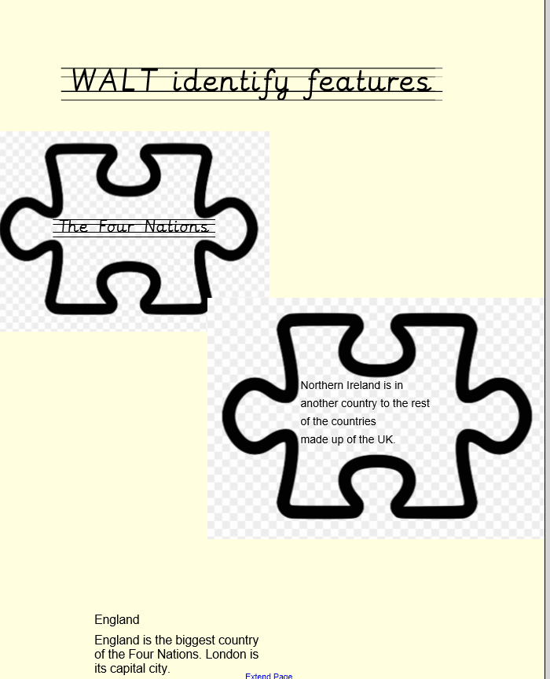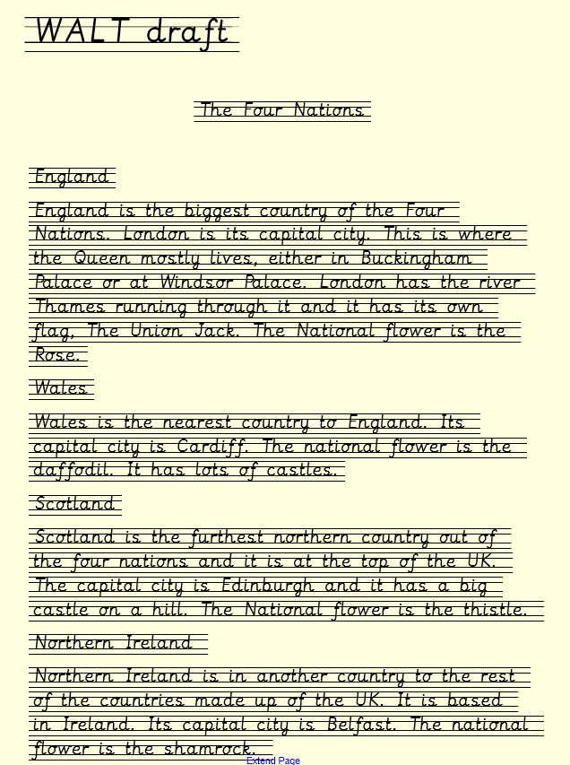  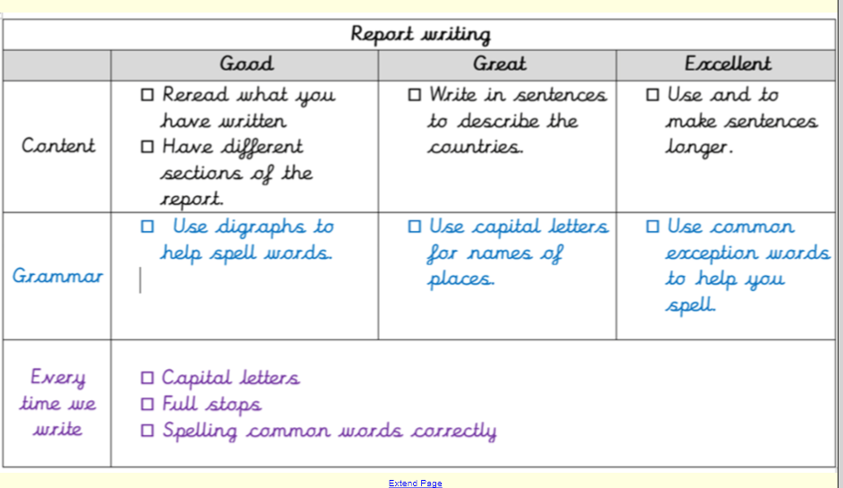  Group 1 (AL)- children to draft their first report.  Group 2 (I) –child to draw and paint a quality picture of the four nations (see sheet).  In afternoon-  Children become delegates from 4 home nations to discuss how to attract/persuade tourists arriving at airports not just to visit London. Discussion - which should be England’s national song to use at football matches, sports games and other events?  Teaching Outcomes  Identify unique aspects of UK’s 4 nations to entice and persuade people from other cultures to visit wider area than only London.  Contribute to the debate.  Explain viewpoint to another.  Be persuasive.  Tourism in the UK from wikipedia.org  Tourist figures to the UK from visitbritian.org  PM on why Jerusalem should be the English National anthem from telegraph.co.uk  Land of Hope and Glory − YouTube clip
Wednesday | Subtract by finding a part. | Watch powerpoint together. Use whole / part/ part and counters to support.  Adult led: Complete part part whole.  Activity 2 : Have part part wholes with whole and one part filled in – can the children use counters to work out the missing part.  PERSONAL BEST and  Performance of learning .(onto website by Friday)
Thursday | WALT: Count back  WALT: Deliver | Count back powerpoint. Have numberlines for children to use to answer questions.  Adult led: numberline calculation sheet.  Activity 2: Race to Zero activity. In pairs, each child has a numberline and dice. They start at 10 and count back number they roll. Who is first to zero?  Afternoon: Children make bauble using materials and their plan. Talk with the children as they create – do you need to change your plan as you go? Photo on tapestry and record responses.
Firday | WALT: count back  WALT: Evaluate | Samrt board pages 8 – 10. Use numberliens to support.  Activity 2: turn over calculation card, solve and record subtraction sentence in books – use numberline to support.  Activity 3: colouring by number calculation  Afternoon: Evaluate their design on sheet.

