Activity 1

11.11.20 WALT: add

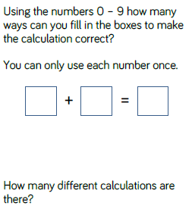

_______________________________________________________________________________________________

Activity 1

11.11.20 WALT: add

