Tuesday
WALT: identify natural and man-made rocks

Match the definition to the rock type:
Natural Rock Type | Definition
Igneous | This type of rock is formed by a chemical reaction whereby the original rock is heated and changed
Sedimentary | This type of rock is formed from molten rock
Metamorphic | This type of rock is formed under the sea using a layering process

Match the rock to the correct group:
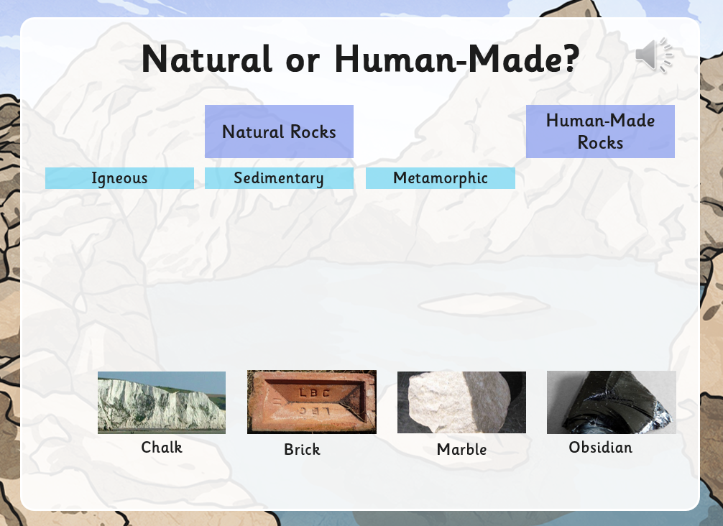
Fact or fiction? Decide if the following statements are fact (true) or fiction (false)
