Tuesday
WALT: Explore volcanoes

Starter – Rank, think talk: layers of the Earth

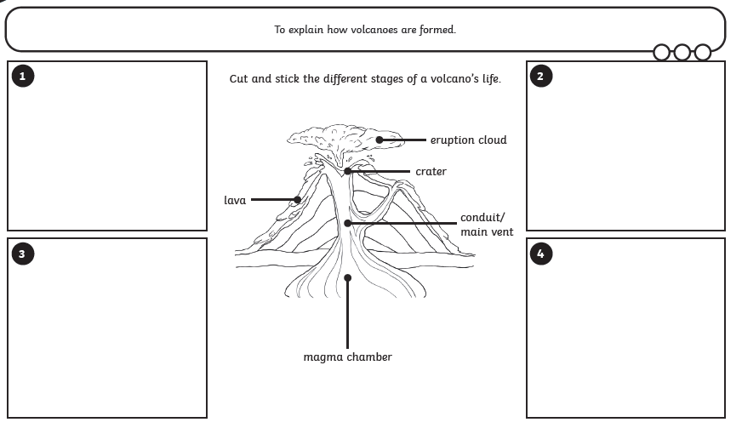
Label the parts of the volcano and then cut and stick the stages to show how they are formed.
Word Bank:
- Eruption Cloud
- Magma chamber
- Crater
- Main vent / conduit
- Lava

