Tuesday 5th January 2020
WALT: name and label the layers of the Earth

Whole Class Discussion Starter:
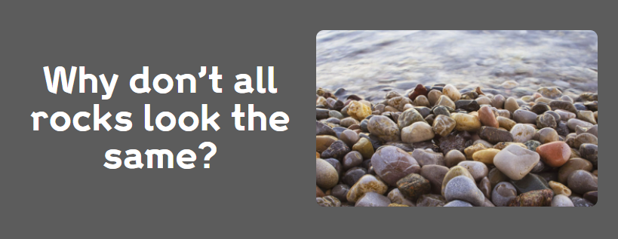

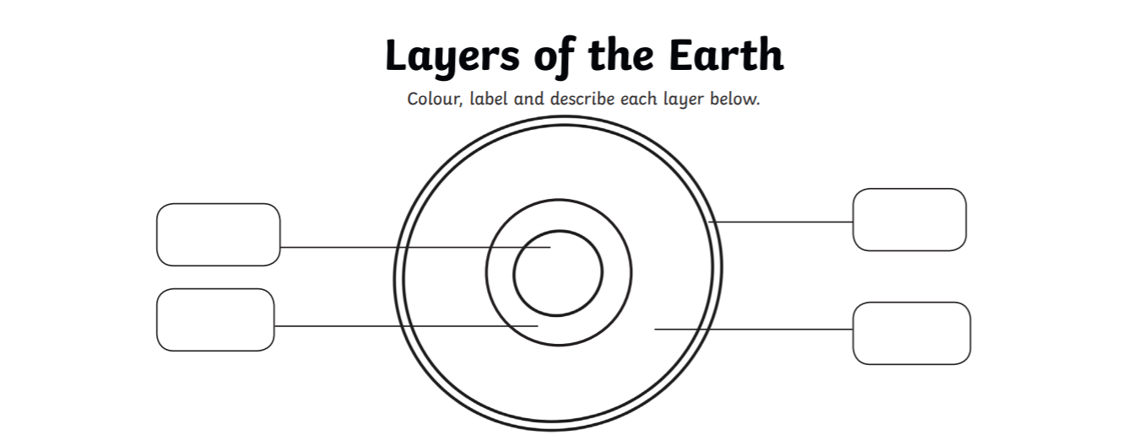
Main Task – Name and label the layers of the Earth
Can you tell me a fact about each layer?

Crust ______________________________________________________________________________________
Mantle _____________________________________________________________________________________
Inner Core _______________________________________________________________________________
Outer Core _______________________________________________________________________________

